**MODULE-5**

**INTRODUCTION TO HANDWRITING EXAMINATION**

**Introduction**

Handwriting is so unique that it can be analyzed. This is because all children learn to print or write cursive by copying the same models of letters, but each child copies just a little bit differently. Over time and with use, those differences become more pronounced. By the time we are teenagers, our ability to write is automatic. As adults, our handwriting is unique to each of us. As we age, our handwriting changes under stress, with different health issues, etc., and continues to evolve and change right up until the day we die.

Among the many handwriting traits that can be analyzed are slant, speed, size, spacing, pen pressure, and position of handwriting on the page, as well as the finer characteristics of each letter, including the cross bars on t's, the dots on i's, and the height and width — even the absence — of loops. No two handwriting samples by two different writers are ever exactly the same, no matter how similar they may appear to be on the surface.

Handwriting analysis is taught at universities in Europe and in workshops and seminars throughout the United States. It is most widely accepted and used in the United States when applied to forgery detection. However, since 1970, even the psychological interpretation of handwriting has become more widely accepted and is used by some experts for personnel selection and for the profiling of unidentified writers.

**Writing Forms and Qualities**

Writing is far from a lifeless form. Every specimen reveals an animation that is individual to its writer and reflects the pen movement that produced it. At one extreme is smooth, continuous, rhythmic, rapidly executed writing, filled with grace and poise, and artistically shaded with points of emphasis that display freedom of movement characteristics of highly skilled penman. Movement of the writing instrument is generally governed by the muscles in the forearm, although the wrist, hand and fingers also may play a part in controlling the pen.

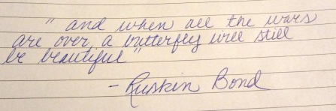

***Handwriting of highly skilled writer is marked by freedom, rhythm and clarity***

In direct contrast is hesitant, interrupted, laborious, slowly executed writing produced by an unskilled or uncertain hand. Its erratic pen strokes, angular connections, and irregular movements are typical of those for whom writing is a difficult physical or mental task. The unsteady appearance of the writing is mainly due to finger movement utilized by the writer to direct the writing instrument.

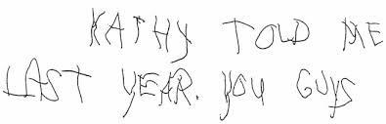

***Handwriting of an unskilled writer appears slowly and awkwardly executed***

There are other qualities of writing movement. Pen strokes can be written precisely or carelessly, or they might be reworked or retouched in an effort to perfect and improve legibility. Some writers have acquired the habit of adding strokes to certain letters that can carry considerable weight in a handwriting comparison. Movement of the pen does not necessarily begin or terminate at the start or finish of a word. With most writers, the pen is in motion before it first make contact with a document and continuous after it is lifted from the paper. These conditions are reflected by tapered initial and terminal pen strokes at the beginning or end of words. In another class of writings, the pen is carefully placed on the document before any writing movement is undertaken and remains in contact with the paper until after each word is completed. Handwriting belonging to this group is characterized by blunt or bulbous initial and terminal strokes. The writing of most people lies between the two extremes, displaying varying degrees and combination of these qualities.

Many writers hold and handle the writing instrument in a very personal manner, which may affect the appearance of their writing. Most modern writing instruments, particularly ball point and soft-tip pens as well as the pencil, do not reveal clear cut evidence regarding the position of the pen relative to the paper or the line of writing. However, Vastrick reported that sister’s lines appearing on zinc-oxide coated paper, no carbon required paper, and certain business form can indicate the handedness of a writer and the orientation of the writing instrument relative to the paper. This is contrast to the nib pen, especially the semi-flexible point of the fountain pen, which produces significantly different shading patterns depending on the relationship of its tip to the paper. While unusual pen positions can be recognized when examining writing produced by a nib pen, such determinations are rarely possible when handwriting has been produced by a pencil, ballpoint or soft-tip pen.

Line quality is perhaps the most important characteristics used to describe handwriting. Albert S. Osborn, who authored Questioned Documents in 1910 and recognized by most as the father of forensic document in North America, introduced the term to embrace all of the factors related to movement that can be derived from a study of writing. It encompasses many features that stem from the dynamic processes used to guide the writing instrument as it is moves across the paper. These elements include pen pressure or emphasis, speed of execution, pen lifts, the consistency and uniformity of the writing, rhythm, and writing skill. Handwriting that exhibits poor line quality throughout may have been produced by inexperienced writers or those who suffer from a physical or mental disability.

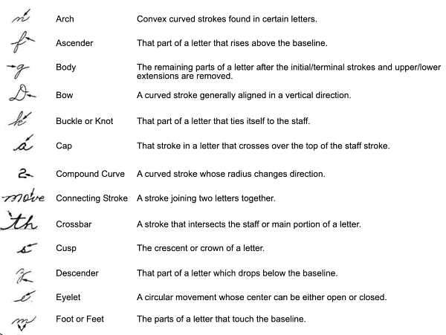

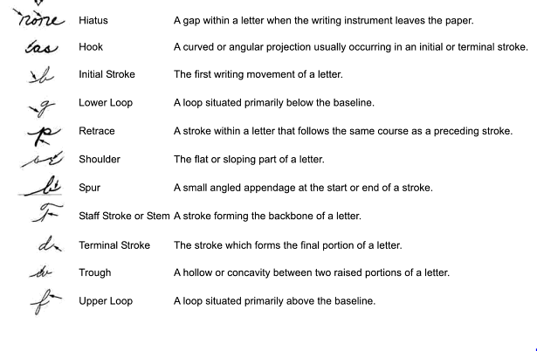***Handwriting expert often use special terms to describe parts of certain letters***

**Handwriting Features**

No study of handwriting is complete without consideration of all its factors, for together they describe the most fundamental properties of writing by an individual. They comprise both obvious characteristics of the writing, such as letter formation, and less conspicuous elements, such as pen pressure and the alignment of parts of a letter relative to the letter as a whole. Features considered when conducting a handwriting comparison include, but are not limited to, the following components.

1. **Abbreviations**

Writers occasionally use abbreviations for words that appear frequently in their written work. These include day abbreviations (e.g., Mon, Tues., etc.) month abbreviation (e.g., Jan., Feb., etc.), and title abbreviations (Rev., Dr., Cst., etc.), to name just a few. Apart from individual features related to the formation and execution of letters in these abbreviations, some writers adopt conventions that are grammatically incorrect, for example, using incorrect contractions to denote the possessive, as in “Science should know its limits” or “You’re computer is too slow”. Abbreviations throughout a written passage can serve as useful identifying features- especially if they are incorrect, such as using “blgd.” to denote building instead of the correct abbreviation “bldg.”

1. **Alignment**

The baseline in a handwritten is the ruled or imaginary line on which the writing rests. In most cases, however, only certain letters or letter combination are misaligned.

1. **Arrangement**

When comparing questioned and specimen extended writing, many factors other than pure handwriting characteristics can and should be considered. The arrangement of writing on a sheet of paper may be individual as the writing itself. Margins, spacing, address, placement, crowding, insertions, and alignment can all be personal habit of a writer; spelling, punctuation, phraseology, and grammar can indicate the writer’s mother tongue or aid in identifying the author of a questioned document. Every one of these factors can be personal and important when identifying the writer of a contested document.

1. **Connections**

Strokes connecting adjacent letters or adjoining words in a handwritten document can be quite unusual. Individuals who produce writing that is compact often use short connecting strokes to join words and letters together, while writers who employ long connectors expand their writing beyond what can best be described at normal limits.

1. **Initial Strokes**

Copybook forms prescribes the proper length, shape, and starting position of initial strokes for cursive letters, with most letters beginning on the baseline. Many individuals have modified this element of their writing to suit their personal tastes. Some writers will start the initial strokes of their letters well below the baseline, while others will commence them above the recommended starting position. There also are writers who use long and short initial strokes, depending on the particular character and its position in a word.

1. **Pen Lifts**

Pen lifts occur when the writing instrument is lifted from the paper. The presence or absence of the interruptions in pen strokes is often an important consideration when determining the genuine or fraudulent nature of a handwritten document. Natural handwriting produced largely by hand and finger movements in more apt to contain pen lifts than writing that is largely executed by the wrist and forearm. In the first instance, movement of a pen is limited by the reach or extension of the writer’s fingers. Once the fingers are fully extended, the pen must be lifted from the paper so the hand can be moved before continuing with the next series of pen strokes.

1. **Pen Pressure**

Pen pressure is the average weight or pressure unconsciously applied to the writing instruments during the act of writing. The operative words in this definition are average weight, which implies it is the average force with which the pen contracts the paper that determines whether a body of writing was written with light, medium or heavy pen pressure.

Writing produced with nib pen will clearly show the effect of applying different amounts of pressure to the writing instrument as it passes along the paper. The more pressure applied by the fingers and hand, the greater the tip of the nib will separate. Occasionally a furrow will be visible in the surface of the paper that is proportional to the amount of pressure applied to the pen. The depth of the furrows can easily be seen if the pen stroke is examined microscopically while illuminating the document with oblique lighting.

When dealing with documents written with ballpoint pens, greater pressure applied during the writing process will cause the tip of the pen to push further into the paper, resulting in a slight thickening of the line and depression of the paper fibers under the written strokes.

1. **Punctuations**

Punctuation marks, such as period, commas, exclamation points, colons and semicolons, are signals that help readers understand the meaning of documents and read them more effectively and efficiently. Rules governing the proper use punctuation appears in writing style guides.

Punctuation marks can appear profusely throughout a questioned document or they may not appear at all. Writers typically follows fixed pattern when writing personal and business letters or addressing envelopes. The FDE should pay close attention to where they are used as well as their shapes and positions relative to the baseline.

1. **Rhythm**

Rhythm is defined as regularity in the curvature of the writing, taking into account spacing characteristics and the graphic patterns established as the pen repeatedly returns to the baseline. The skilled writer will usually produce handwriting that is pleasing to the eye and that contains a recurring series of stress and impulsive movements produced by the hand. Consequently, poor rhythm is one feature that distinguishes freely executed handwriting from the crude product of a tracing or freehand simulation.

1. **Shading**

Shading, as opposed to the unconscious application of pressure to the writing instrument is the conscious or voluntary act of applying pressure to the pen while completing certain strokes. However, the effect of applying pressure to the writing instrument is the same each instance. When a nib pen is used, pen strokes executed with heavy pressure will be wider than strokes written with less pressure. In the hand of skilled penman, a nib pen will produce shading that gives the writing an artistic quality that is pleasing to the eye.

One might think the non-flexible quality of the ballpoint pen will produce pen strokes entirely devoid of shading or evidence of pen emphasis; however, this is not entirely the case. Even though ballpoint pens produce lines that have more uniform widths, some writers nevertheless execute writing that clearly reveals differences in writing pressure.

An assessment of shading in a handwritten document not only encompasses the amount of pressure applied to the pen, but also the region where shading begins and ends. Like all learned behavior, shading is an acquired writing habit developed through years of repetition and practice.

1. **Size**

Unless confined to a restricted space or written at different times, the size of writing by most individuals is rather consistent. The size of a writing can be influenced by the circumstances surrounding the writing act. For example, Alford reports that approximately 65% of writers reduce or increase the size of their writing as a means of disguise. This result was also found in a study conducted by Hardy et al. although change in the size of natural writing by the same individual occur from time to time, the relative size of capital and lowercase letters is usually constant.

1. **Slope**

One of the most obvious feature is in individual’s handwriting is its slope or slant. Writers who intentionally alter the slope of their writing cause a dramatic change to the appearance of letters. This is why modifying the slope of handwriting is a common method of disguise. While gross change in writing slant are relatively easy to achieve, slight changes in the slope are exceedingly difficult to maintain and are rarely consistent throughout an extended passage of writing.

1. **Terminal strokes**

Like initial strokes, terminal strokes also are prescribed by copy book forms. Individuals who acquire a personal style of writing invariably deviate from letter forms dictated by the copybook and will curled strokes, extensions, or embellishments to the end of certain letters. These writing features are quite consistent and, therefore, warrant consideration when comparing two groups of writing.

1. **Tremors**

Tremor can be due to involuntary shaky movements of the hand as a forger slowly copies a victim’s letterforms. In these instances, tremor is likely to occur in letter or letter combinations that require the greatest skill to produce. Consequently, broad curves and intricate writing movements should always be inspected microscopically for irregular thickening in pen strokes and deterioration in line quality, as they represent the greatest challenge to the forger.

Tremor also can result when writers are attempting to alter or disguise their normal handwriting habits. Disguised writing does not have the spontaneous appearance of naturally executed words and letters. The practice of concealing one’s natural writing habits while simultaneously writing in a completely different manner requires tremendous concentration and effort if the deception is to avoid detection.

Genuine writing formed under unusual circumstances can contain tremor as well. It appears in varying degrees if writer is suffering from a loss of muscular control due to a debilitating illness or old age. Those who suffer from diseases like Parkinsonism may find temporary relief by taking prescribed medication.

One of the most challenging problems confronting the FDE is determining the cause of tremor in a questioned document. Some important factors to consider include where the tremor occurs, the extent to which the pen deviates from its normal path, and the writers condition when the document was allegedly write.

**Disguise writings**

Disguised handwriting is the willful modification of a person's natural writing for the purpose of concealing identity. As a subject it is growing in importance. Nowadays persons can be convicted of forgery on handwriting testimony alone, and this fact motivates many criminals to disguise their handwriting in an attempt to evade justice.

Disguised handwriting test for the past 17 years John L. Harris, Examiner of Questioned Documents, Los Angeles, has tested each student in his university [Vol. 43 disguised handwriting classes 1 on ability to disguise handwriting. Students are given a 5 x 7 inch ruled card and told to copy the following letter:

Most laymen have the classic impression that disguise means grotesque writing as found in blackmail and kidnap notes and in some anonymous letters. Actually, grotesque disguise is the exception. Disguised writing is used more frequently for passing fictitious checks and writing comparison specimens. Therefore, the most common and practical disguise is one which attempts not only to keep the writer anonymous but that also appears to be natural handwriting, thus arousing no suspicion.

Disguised handwriting is most commonly used in the following situations:

1. Writing fictitious checks.
2. Endorsing stolen checks.
3. Writing anonymous letters, extortion notes, etc.
4. Submitting handwriting standards.
5. Signing name with the purpose of denying signature later on.

Methods of disguise vary with the ability and imagination of the writer. An extreme change of slant is the most popular means and the least effective method of disguise. Other writers concentrate more on letter formation and ignore slant changes. In a recent Los Angeles case an anonymous letter writer, posing as an 18 year old girl, attempted to design his disguise to fit the personality of the imaginary girl. He wrote daintily, used circular eye dots, etc. and was effective enough that early in the case one officer described the writer as an immature girl. The writer turned out to be a 47 year old man who drew on his drama teaching experience to create an affected girl's handwriting.

A few persons are ambidextrous and, therefore, have quite a talent 685 JOHN J. H.4RRIS for disguising handwriting. Occasionally, check passers are arrested who have written checks with one hand and then submit disguised specimens using the other hand

Pen lettering or printing is a commonly attempted method, because of the general impression that printing cannot be identified. Obtaining proper standards is usually the most difficult problem to solve in these cases.

An unusual disguise is writing upside down and backwards, and another is by copying someone else's handwriting, or by combining both of these methods.

Disguised handwriting fails to accomplish its objective in the same way that a forged signature fails to imitate genuine writing. There are characteristics of disguise which label such writing as artificial just as hesitation, pen lifts, and careful retouching can point to forgery.

Inconsistency is the most important characteristic indicating disguise. Frequent changes in slant, letter formation, spacing, pen pressure, size, and legibility are indicative of the writer's effort to create new handwriting characteristics in place of his own natural writing habits. The dual process of eliminating the old and creating the new is not unlike a driver reaching for the gear shift in his first hydromatic car.

Usually, only the most obvious features are disguised. For example, capital letters are disguised more often than small letters. Grotesqueness is another characteristic, and it is often very difficult to identify writing consisting of weird and fantastic patterns.

Slowness and hesitation can also be found in disguised writing caused by the writer deliberating in order to avoid his natural writing habits. Backhand slant is another characteristic since many people just assume they are disguising by changing slant. A careful disguiser may check his work and go back and touch up letters attempting to make the writing consistent. The over-writing and correcting of naturally written letters is strong evidence of the writer's attempt to deceive.

Our greatest aid in solving these problems is the perpetrator's lack of knowledge of how to disguise his handwriting. Few persons can describe their own writing, which weigh the odds heavily against them ever being successful in disguising it.

**Writing variations**

It has been said that any two objects larger than molecular size contain variation. And so it is with handwriting. We never write anything exactly the same. Every time we write, our writing is slightly different. Sometimes a little larger, sometimes smaller, faster, slower, more angled, less angled, and on, and on. Our individual characteristics will be slightly different each and every time we pick up a pen.

The parameters of an individual’s handwriting are defined by these small changes to individual characteristics. For this reason the questioned document examiner may require numerous handwriting specimens to provide a basis for a viable comparison to a questioned writing. The comparison process is not that of determining if two writings are exactly alike, that will never occur; it is a determination of whether the questioned writing or signature fits within the parameters of individual variation exhibited in the standard material.

Simply put, when an ample quantity of handwriting containing a pattern of sufficient unique habitual movements, or individual characteristics, produces a totality of similarity within the parameters of individual variation with another body of writing, it must be concluded that both writings are the product of one person.