**MODULE-3**

**EXAMINATION OF MECHANICALLY GENERATED DOCUMENTS**

**Introduction**

Since ancient times, various writing instruments have been used to communicate the written word. Today quill and nib pens have given way to other classes of writing instruments, namely the ballpoint, porous tip, roller ball and gel pens. A number of special types of pens, including those used for drawing, lettering and artwork, are also currently marketed. Each class has its own identifying characteristics potentially distinguishing it from the others. The use of particular pen or ink class often has importance in the investigation of a disputed document, particularly when there are issues of backdating, insertions or other alterations.

Recently, I had to study a case in which some disputed signatures were written with pencil, while the standards of comparison were written with pen and ink. I looked in the literature in order to find documentation on that peculiar problem, and I noticed that most of the specialists in the field of handwriting of signatures examination had treated very superficially the question of the influence of the utilized instrument on handwriting or signatures (1-19). Most of these authors only remarked that it is preferable to depend upon specimens written with pencil when the disputed document is written with pencil, to depend upon specimens with a fountain pen if the disputed document is written with a fountain pen.

Page 22 of Questioned Documents (17), A. S. Osborn writes: "The most significant form characteristics of pencil writings are in general character the same as those in pen writings by the same individual and a questioned document in pencil may be properly compared in this particular with pen writing. and further: "Shading, pen pressure, pen position and line quality characteristics are not exactly the same in pen and pencil writing, but such differences will not render one kind of writing entirely useless as a proper standard for comparison with the other, but would tend to weaken its value. Some writers make considerable distinction between their pen and pencil writing, while others do not, and this fact also should always be determined and considered."

1. ***Ball point pen***

Ball point pens have a hard, non-flexible point; a small rotating ball which rolls the viscous ink on the surface of the paper. The viscosity of the ink varies from one manufacturer to another, and different ball diameters exist, but these elements have no important action on the constitution of the stroke itself, for the study of the problem of the influence of the instrument either on the handwriting or on the signature. When one writes with a very weak pressure on the ball point pen, only the top of the ball touches the paper and lays out a narrow stroke which is made up of a layer of colored matter deposited on the ridges of the paper fibers. In such a case there is practically no relief on the back of the sheet, even if the paper lies on a soft support. When one writes with a strong pressure on the ball point pen, and if the support on which the paper lies is soft, the ball depresses the paper, producing a marked relief on the back. Under these conditions, the major portion of the ball touches the paper and lays out a wide stroke (the width of the stroke is naturally always less than the diameter of the ball itself) on the ridges of the paper fibers and, sometimes too, between the fibers in the furrows.

It appears, contrary to the common opinion, that, it is perfectly possible to produce strokes of variable width while using a ball point pen. The nature of the paper and of its surface does not have a great influence on the appearance of the strokes.

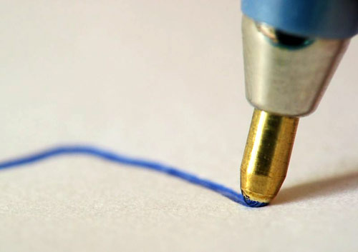

1. ***Porous-Tip Pens***

The porous-tip pen has been popular writing instruments for several decades, having been introduced in the mid-1960s. The writing point of this pen is porous and allows a supply of aqueous (water soluble) ink to be spread on the paper. While broad tips predominated in the early pens, fine and very fine tips are now commonplace. Some porous tips pen utilize a hard, perforated plastic tip. The hard tip pens produce a stroke very similar to the pure fiber tip pen, except that under some conditions they can create a slight furrow or trough. With all, the ink tends toward intense color and the pens deliver a heavy, though quick drying line. The ink lines produced with a porous- tipped pen can be contrasted with the product of ballpoint pen. When properly functioning, the former creates a broad, solid and ribbon like stroke. With light pen pressure and rapid execution, ink lines will sometimes have a streaked or brush stroke appearance. A particular pen rarely develops enough individuality to distinguish it from others containing similar ink; however as with ball point pens, many tip widths are available and can be distinguishing factor. Pens of this class are factory filled and are generally disposable.

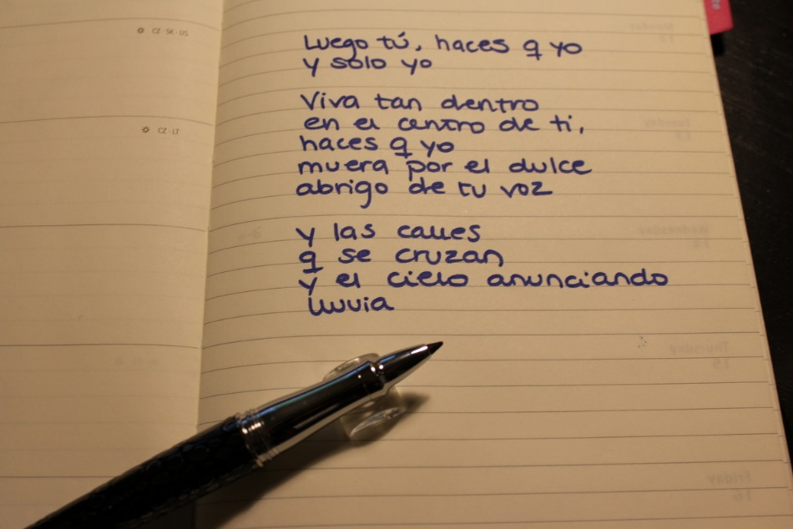

1. ***Roller ball pens***

It was only few years after the introduction of the ballpoint pen that the first attempt was made to adapt this design to use fluid ink. It was not until the late 1960s that such a pen was perfected to write with sufficient reliability to ensure general acceptance. This class of writing instruments represents a hybrid of the fountain and ballpoint pens. Like the porous tip and fountain pens, the ink used is water based. The pens are sold as either disposable items or refillable with a replaceable ink cartridge that includes the ball. These pens produce a stroke not unlike that of a porous tip pen, except that the ball tends to emboss the paper, creating a trough much like that seen in the work of ballpoint pen. Differences in ink distinguish this product from that of the conventional ballpoint pen. The ink generally saturates the paper with slight bleeding into adjacent fibers, and ink flow-back can often be seen at the end of the stroke. Unlike ballpoint pens, they do not exhibit the characteristics of skipping and gooping. Some stroke defects do appear with use, but a particular pen typically does not develop sufficient individuality to distinguish it from others of the same class.

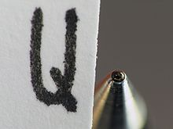

1. ***Gel pens***

This newest class of gel pen has become a very popular writing instrument throughout the world. It was first developed by Sakura Color Products Corporation of Japan in 1984. Sakura was interested in producing a writing instrument that was environmentally friendly and did not contain volatile organic components such as those found in roller ball pens. Initially this class of writing used a high viscosity, pigment based opaque ink, which does not tend to bleed into the paper fibers as much as is found with water based roller ball or porous-tipped pens. Modern black gel inks incorporate both dye-based and pigment coloring. A broad range of ink colors are available and can generally be seen through the semitransparent barrel. Some varieties are advertise as suitable for arts and graphics, including those that use an ink that is metallic in appearance. Given the vast array of colors available, these pens are very popular among children and artists. Like ballpoint and roller ball pens, the ink is delivered using a housed metal ball. Pilot, Zebra, and Pental are common brands. One characteristics that can be used to differentiate its ink line from that of other writing instruments is a tracking effect along the outer edges of the ink stroke. While this effect is not necessarily seen throughout an entire writing, it is nevertheless a common occurrence and suggests that the ink is being pushed by the ball to the outer edges of the stroke.

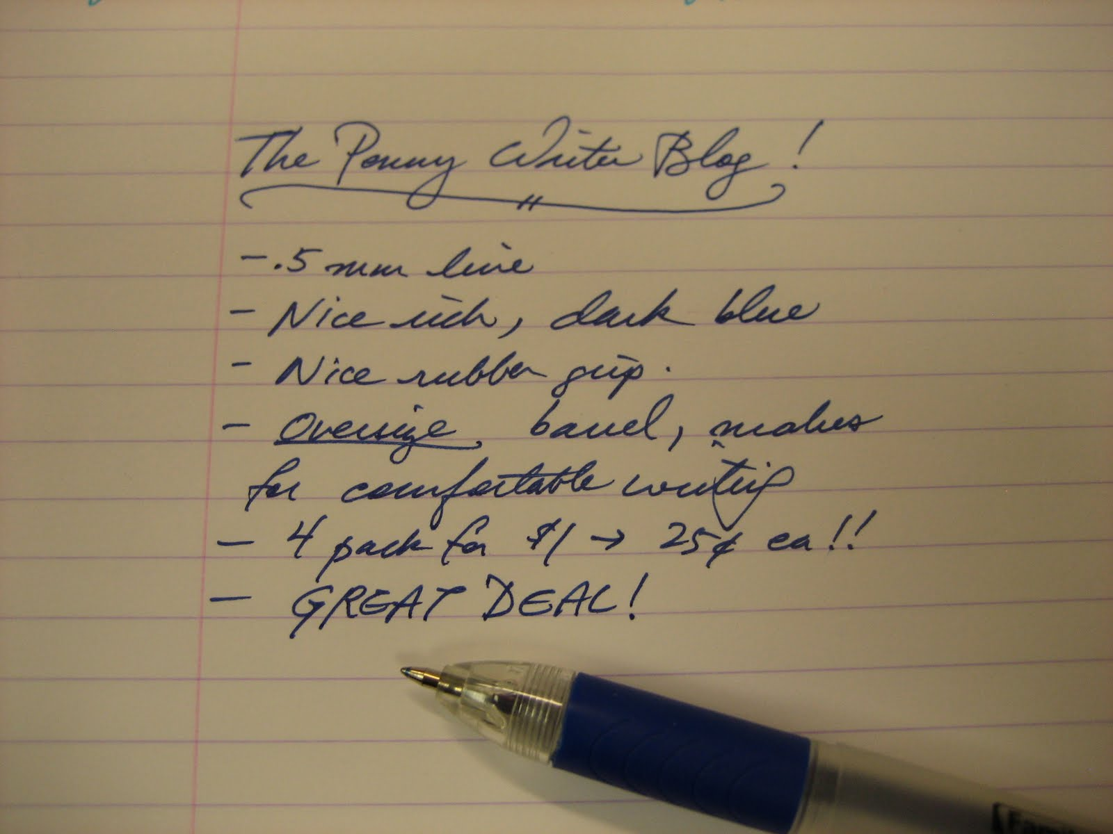

1. **Fountain or Nib Pens**

Today the fountain and nib pens are more assign of prestige than a commonplace writing instrument. An individual may select this class as his or her official signing pen, while using other writing instruments for everyday use. The writing characteristics vary. The nib point width and its flexibility are two characteristics of this pen. Occasionally, a steel-pointed dip pen may be encountered, especially where very old documents are concerned. Normally, a particular nib pen cannot be identified as the source of a specific writing, as it lacks individuality in its ink line morphology. Still, not all of these pens produce the same writing strokes, which makes it possible to stay in some situations that a certain pen was not to execute a questioned document or that more than one person was used.

Nib pens produce a stroke different from those of other types of pen. The nib can make a distinctive, a darker double track within the stroke, but this double track is not as pronounced with modern, stiff-pointed fountain pens as it is with more flexible points. The ability of fountain pen to provide sufficient ink to execute lengthy documents with comparable ink densities from page to page can distinguish it from the steel dip pen. The latter produces more intense writing each time it is filled, and gradually the intensity of strokes diminishes. If the point of fountain pen is flexible, definite shading can be a part of the writing, which is recognized by the gradual increase in the width of the stroke due to the pressure of the pen, particularly on down strokes.

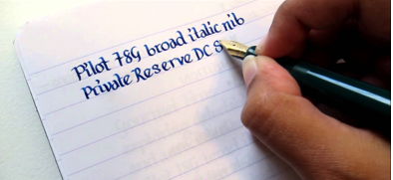

1. **Writing inks**

The history of ink date back to ancient times. Among the earliest material used was carbon, which produces a very permanent ink. Today it is still employed in certain drawing inks, which produces a very permanent ink. Today it is still employed in certain drawing inks, often referred to as inks. During the Middle Ages iron gall ink was developed. A characteristics of writing produced with iron gall ink is its oxidation and resulting fade from black to brown. The ink’s corrosive nature also has the effect of eating through the paper on which it is applied, a phenomena observed in many historical documents. It was ultimately improved to become blue black ink and was widely used until the ballpoint pen became the most popular and common writing instrument.

Various natural dyes were initially adopted for colored inks. With the introduction of aniline (discovered in 1856) and other systematic dyes (such as synthetic indigo, 1861) these natural dyes were gradually replaced. The changeover came in the late 1800s and early 1900s. During the 1930s dyes were developed that required the use of strong alkaline solution instead of the mild acid ink. The newer ink enjoyed limited commercial popularity. With all of the inks discussed to this point, water was the chief solvent.

With the invention of the ballpoint pen in the mid-1940s came a different type of ink. It is a thick, paste like material using organic chemical solvents rather than water. In this respect it resembles inks used in old style typewriter ribbons and in the printing industry, although ballpoint pen ink has its own special properties.

Since the 1970s fluid water based inks have found expanded use, first in the porous- tip or fiber tip pen, and more recently roller ball pens. The fiber-tip pen marked a modifications of the felt marking pen, which had some specialized use an employed a non- water based ink. Synthetic dyes and pigments form the coloring matter in almost all present-day ink.

Just like there are different types of pens for writing, there are also different types of ink. All pen ink shares two basic ingredients: a colorant and some kind of liquid or solvent, but the characteristics of the ingredients vary greatly depending on the type of ink. Inks also have additives such as surfactant for smooth flow, fungicides to prevent fungal growth and buffering agents to control the pH and give the ink desirable writing characteristics.

**Ballpoint Pen Ink**

Ballpoint pen ink contains an oil-based solvent and pigment for color. The ink flows from a thin tube or canister in the pen and through a small ball in the tip of the pen when you apply pressure to the ball. Standard colors for ballpoint ink are black, blue, red and green. Ballpoint pen ink dries almost instantly as it touches paper, but because it is oil-based, it can smear.

**Drawing Pen Ink**

Ink for drawing pens is water-based and contains dye rather than pigment for color. Drawing ink requires a drawing pen which you dip into the ink. The ink collects on a nib at the tip of the pen. Drawing ink is very thin, and it takes practice and patience to use the pen without smearing or dribbling the ink. Because drawing ink contains dye, it can fade over time. Artists and calligraphists typically use drawing ink.

**Fountain Pen Ink**

Fountain pens are similar to drawing pens, but have a refillable cartridge that holds a small quantity of fountain pen ink which eliminates the need for dipping the pen in ink. Fountain pen ink is water-based and contains dye for color, but also contains a surfactant which controls the flow of ink when the nib comes in contact with paper. Fountain pens are less likely to dribble or leave blobs, but the ink still requires a short drying time.

**Rollerball Pen Ink**

Rollerball pens are similar to ballpoint pens, but use water-based or gelled ink and require less pressure on the rollerball tip to write. The ink for these pens is less viscous than oil-based ink and deeply saturates the paper, resulting in a dark color. Gel ink contains pigments where water-based ink has dyes for color. Rollerball pens come in a variety of colors due to the wider choice of water-soluble dyes and vibrant pigments.

**Gel Pen Ink**

Gel pen ink contains colorful pigment suspended in a thick, water-based gel. The high viscosity of the gel supports more pigment than standard gel ink and also accommodates different types of pigments such as copper and iron oxides. Gel pen ink is thick and opaque and available in almost every color including white. Bright neon, metallic flake and glitter are other unique characteristics of the ink. Gel pens are similar to rollerball pens in that they have a rollerball to distribute the ink from a small reservoir inside the pen.

1. **Pencils**

Like pens, pencil can be grouped into classes based on their physical properties. There are three general categories: encased graphite, encased color; and mechanical. In the course of manufacture, the graphite forming the making substance is mixed with clay and waxes and then baked. The amount of graphite and clay and the period of baking are factors that determine the hardness of the lead. Pencils designed for drawing range from very hard to very soft, capable of making only a light stroke, even with heavy pressure, or of making relatively dark lines with only slight pressure. There are also several grades of common writing pencils.

These instruments can be identified in a general way by their relative grade or firmness. Writing pencils have numeral designations, with 1 being the softest and 4 being the hardest. Artists drawing pencils are distinguished separately, with 8B being the softest and 2H the hardest.

Inexpensive pencils are made with less graphite and clay, while the top grade pencils use fine materials and are manufactured under excellent quality controls. Microscopic study of pencil strokes helps to differentiate between the cheaper and more expensive writing leads. A small percentage of pencils use resin as a substitute for the clay base. Their appearance is not substantially different. Mechanical pencils can use lead that is either clay or resin based. The polymer leads are most often used by draftsmen. Lead sizes in this latter category include, but are not limited to, 0.3, 0.5, 0.7, and 0.9 mm and vary in hardness.

When a specimen of pencil writing is examined, it may be very difficult to establish the particular hardness of the pencil used, although blood grouping, such as soft, medium or hard, may be recognized. The difference between two adjacent grades prepared by the slightly different effects because of individual habits of pressure and emphasis. Furthermore, a change of writing background from a hard table top to a softer writing pad impacts on the density of the strokes produced, as does the relative sharpness of the point. Softer points in wood-encased pencils may wear down appreciably during the writing of several pages, whereas a harder lead holds its point much longer.

On the other hand, the question does arise as to whether all the writing on a page was prepared at one time and with a single pencil. A sharp change in width, clarity, embossing, or intensity of the stroke may be evidence of two separate writings. A study of the pencil stroke may indicate execution one more than one king of writing surface or with more than one pencil. These conditions are more consistent with preparations of the parts on separate occasions than with continuous writings, but it is not absolute proof of the latter. If the writings was prepared with a mechanical pencil on several different occasions but with the same writing background throughout, they may be little evidence of the interruptions.

**TYPOGRAPHY**

**Typography** is the art and technique of [arranging type](https://en.wikipedia.org/wiki/Typesetting) to make [written language](https://en.wikipedia.org/wiki/Written_language) [legible](https://en.wikipedia.org/wiki/Legibility), [readable](https://en.wikipedia.org/wiki/Readability), and [appealing](https://en.wikipedia.org/wiki/Beauty) when displayed. The arrangement of type involves selecting [typefaces](https://en.wikipedia.org/wiki/Typeface), [point size](https://en.wikipedia.org/wiki/Point_(typography)), [line length](https://en.wikipedia.org/wiki/Line_length), line-spacing ([leading](https://en.wikipedia.org/wiki/Leading)), [letter-spacing](https://en.wikipedia.org/wiki/Letter-spacing) (tracking), and adjusting the space within letters pairs ([kerning](https://en.wikipedia.org/wiki/Kerning)). The term typography also is applied to the style, arrangement, and appearance of the letters, numbers, and symbols created by the process. [Type design](https://en.wikipedia.org/wiki/Type_design) is a closely related craft, sometimes considered part of typography; most typographers do not design typefaces, and some type designers do not consider themselves typographers. Typography also may be used as a decorative device, unrelated to communication of information.

Typography is the work of [typesetters](https://en.wikipedia.org/wiki/Typesetting), [compositors](https://en.wikipedia.org/wiki/Compositor_(typesetting)), typographers, [graphic designers](https://en.wikipedia.org/wiki/Graphic_designer), [art directors](https://en.wikipedia.org/wiki/Art_director), [manga artists](https://en.wikipedia.org/wiki/Manga_artist), [comic book artists](https://en.wikipedia.org/wiki/Comic_book_artist), [graffiti artists](https://en.wikipedia.org/wiki/Graffiti_artist), and now—anyone who arranges words, letters, numbers, and symbols for publication, display, or distribution—from [clerical workers](https://en.wikipedia.org/wiki/Clerical_worker) and newsletter writers to anyone self-publishing materials. Until the [Digital Age](https://en.wikipedia.org/wiki/Information_Age), typography was a specialized occupation. Digitization opened up typography to new generations of previously unrelated designers and lay users, and David Jury, head of graphic design at Colchester Institute in England, states that "typography is now something everybody does." As the capability to create typography has become ubiquitous, the application of principles and best practices developed over generations of skilled workers and professionals has diminished. Ironically, at a time when scientific techniques can support the proven traditions (e.g. greater legibility with the use of serifs, upper and lower case, contrast, etc.) through understanding the limitations of human vision, typography often encountered may fail to achieve its principle objective, effective communication.

**Anatomy of font:**

## [Ampersand](http://www.typographydeconstructed.com/ampersand/)

A stylized character of the Latin **et** used to represent the word and.

Definition: The typographic symbol used to designate the word and (&) is the Latin symbol for **et** which means and. The name, ampersand, is believed to be derived from the phrase “and per se and.” On a Standard English layout keyboard the ampersand (&) is accessed with shift+7. In many fonts the ampersand looks much like a cursive S or a curvy plus sign but in other fonts you can almost see the word Et in the design of the ampersand.



## [Aperture](http://www.typographydeconstructed.com/aperture/)

The partially enclosed, somewhat rounded negative space in some characters. Definition: The aperture is the partially enclosed, somewhat rounded negative space in some characters such as n, C, S, the lower part of e, or the upper part of a double-storey a.



[Apex](http://www.typographydeconstructed.com/apex/)

A point at the top of a character where two strokes meet. The point at the top of a character such as the uppercase A where the left and right strokes meet is the apex. The apex may be a sharp point, blunt, or rounded and is an identifying feature for some typefaces.



## [Arc of Stem](http://www.typographydeconstructed.com/arc-of-stem/)

A curved stroke that is continuous with a straight stem.



## [Arm](http://www.typographydeconstructed.com/arm/)

A horizontal or upward, sloping stroke that does not connect to a stroke or stem on one or both ends. The arm of a letter is the horizontal stroke on some characters that does not connect to a stroke or stem at one or both ends. The top of the capital T and the horizontal strokes of the F and E are examples of arms. Additionally, the diagonal upward stroke on a K is its arm. Sometimes arm is used interchangeably with bar or crossbar or cross stroke.

Arm is often also used to describe the mostly horizontal top stroke of C, double-storey a, G, and other glyphs, to include the finial, terminal, spur, or other elements of the stroke.



## [Ascender](http://www.typographydeconstructed.com/ascender/)

An upward vertical stroke found on the part of lowercase letters that extends above the typeface’s x-height. In typography, the upward vertical stem on some lowercase letters, such as h and b, which extends above the x-height is the ascender. The height of the ascenders is an identifying characteristic of many typefaces. The ascenders of some letters may touch or almost touch letters in the line above causing awkward or distracting patterns. This is most likely to happen or be obvious when a line of text with tall ascenders is below a line of text with long descenders. To resolve the problem of touching ascenders and descenders you can: Increase the leading (line spacing) between lines of type; Choose a different typeface; for headlines and subheads, some careful editing/re-wording can eliminate the problem; Changing the alignment of the text may also help.



## [Ascender Line](http://www.typographydeconstructed.com/ascender-line/)

The invisible line marking the height of ascenders in a font.

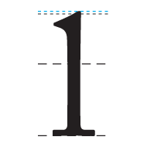

## [Ascent Line](http://www.typographydeconstructed.com/ascent-line/)

The invisible line marking the farthest distance between the baseline and the top of the glyph.

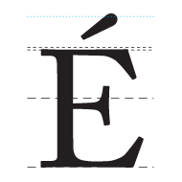

## [Axis](http://www.typographydeconstructed.com/axis/)

An imaginary line drawn from top to bottom of a glyph bisecting the upper and lower strokes is the axis. Definition: An imaginary line drawn from top to bottom of a glyph bisecting the upper and lower strokes is the axis. For typefaces that exhibit changes in the thickness of curved strokes, the inclination of the axis of the lowercase o is used to measure the angle of stress. A completely vertical axis indicates a design with an angle of 0 or vertical stress. When the axis leans to the left or right the design has angled (positive or negative) stress. Early styles of typefaces generally shared similar axis or stress angles.

The axis or design axis is also an adjustable attribute of some fonts, such as Multiple Master fonts. Adjusting the design axis results in variations in the weight, width, size, and other features of the typeface.

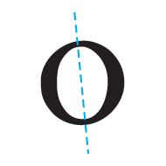

## [Ball Terminal](http://www.typographydeconstructed.com/ball-terminal/)

A circular form at the end of the arm in letters. In typography, the terminal is a type of curve. Many sources consider a terminal to be just the end (straight or curved) of any stroke that doesn’t include a serif (which can include serif fonts, such as the little stroke at the end of “n” as shown in the illustration). Some curved bits of tails, links, ears, and loops are considered terminals using the broader definition (see the Microsoft Typography site for further explanation).

Ball terminal is a combination of a dot (tail dot) or circular stroke and the curved bit (hook) at the end of some tails and the end of some arms (a, c, f). Beak terminal refers to the sharp spur or beak at the end of a letterform’s arm and the curved bit (terminal) between the beak and the arm.

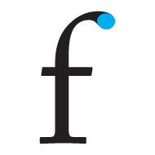

[**Bar**](http://www.typographydeconstructed.com/bar/)

The horizontal stroke in letters. Also referred to as Crossbar. The (usually) horizontal stroke across the middle of uppercase A and H is a bar. The horizontal or sloping stroke enclosing the bottom of the eye of an e is also a bar. Although often used interchangeably, the bar differs from an arm and a cross stroke because each end connects to a stem or stroke and doesn’t (usually) intersect/cross over the stem or stroke. The varying positioning, thickness, and slope of the bar is an identifying feature of many type designs.



## [Baseline](http://www.typographydeconstructed.com/baseline/)

The invisible line where all characters sit. Definition: In typography, the baseline is the imaginary line upon which a line of text rests. In most typefaces, the descenders on characters such as g or p extend down below the baseline while curved letters such as c or o extend ever-so-slightly below the baseline. The baseline is the point from which other elements of type are measured including x-height and leading. The baseline is also significant in the alignment of drop caps and other page elements.



**Type Classification system**

# **Type Classifications**

Most typefaces can be classified into one of four basic groups: those with serifs, those without serifs, scripts and decorative styles. Over the years, typographers and scholars of typography have devised various systems to more definitively categorize typefaces – some of these systems have scores of sub-categories.

A classification system can be helpful in identifying, choosing and combining typefaces. While four categories are clearly inadequate for design professionals, dozens become self-defeating. We have put together a somewhat hybrid system of 15 styles, based on the historical and descriptive nomenclature first published in 1954 as the Vox system – and still widely accepted as a standard today.

**Classifications**

**Serif Type Styles**

* Old Style
* Transitional
* Neoclassical & Didone
* Slab
* Clarendon
* Glyphic

**Sans Serif Type Styles**

* Grotesque
* Square
* Humanistic
* Geometric

**Script Type Styles**

* Formal
* Casual
* Calligraphic
* Black letter & Lombardic

**Decorative**

* Grunge
* Psychedelic
* Graffiti

**Serif Type Styles**

**Old Style**

This category includes the first Roman types, originally created between the late 15th and mid-18th centuries, as well as typefaces patterned after those designed in this earlier period. The axis of curved strokes is normally inclined to the left in these designs, so that weight stress is at approximately 8:00 and 2:00 o’clock. The contrast in character stroke weight is not dramatic, and hairlines tend to be on the heavy side. Serifs are almost always bracketed in old style designs and head serifs are often angled. Some versions, like the earlier Venetian old style designs, are distinguished by the diagonal cross stroke of the lowercase e.

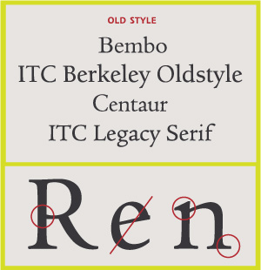

**Transitional Serifs**

English printer and typographer John Baskerville established this style in the mid-18th century. These typefaces represent the transition between old style and neoclassical designs, and incorporate some characteristics of each. Baskerville’s work with calendared paper and improved printing methods (both developed by him) allowed much finer character strokes to be reproduced and subtler character shapes to be maintained. While the axis of curve strokes can be inclined in transitional designs, the strokes normally have a vertical stress. Weight contrast is more pronounced than in old style designs. Serifs are still bracketed and head serifs are oblique.

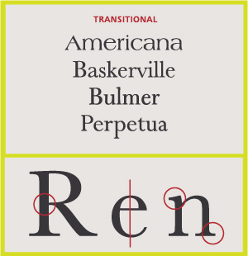

**Neoclassical & Didone Serifs**

These are typefaces created within the late 18th century, or their direct descendants. The work of Giambattista Bodoni epitomizes this style of type. When first released, these typefaces were called “classical” designs. Early on, however, it became apparent to printers that these were not updated versions of classic type styles, but altogether new designs. As a result their classification name was changed to “modern.” Since the mid-20th century, they have also been classified as neoclassical or didone. Contrast between thick and thin strokes is abrupt and dramatic. The axis of curved strokes is vertical, with little or no bracketing. In many cases, stroke terminals are “ball” shapes rather than an evocation of a broad pen effect. These tend to be highly mannered designs, with clearly constructed letters.

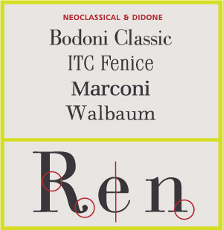  
  
**Slab Serifs**

Slab serif typefaces became popular in the 19th century for advertising display. These typefaces have very heavy serifs with minimal or no bracketing. Generally, changes in stroke weight are imperceptible. To many readers, slab serif type styles look like sans serif designs with the simple addition of heavy (stroke weight) serifs.

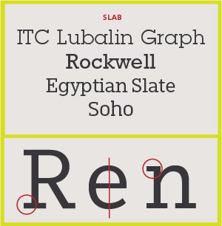

**Clarendon Serifs**

This category includes the typefaces patterned after the Clarendon type styles first released in the mid-19th century. Clarendons were designed as bold faces to accompany text composition. Their stroke contrast is slight, and serifs tend to be short to medium length. Later, many of these designs were released at larger point sizes as display types. Character stroke weight that is more obvious, and serifs that tend to be longer than earlier designs, mark more current interpretations of this style.

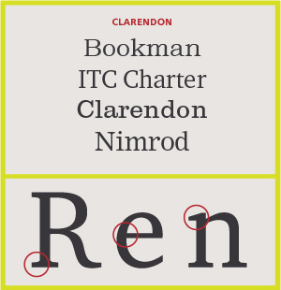

**Glyphic Serifs**

Typefaces in this category tend to emulate lapidary inscriptions rather than pen-drawn text. Contrast in stroke weight is usually at a minimum, and the axis of curved strokes tends to be vertical. The distinguishing feature of these typefaces is the triangular-shaped serif design, or a flaring of the character strokes where they terminate. In some type classification systems this category is sub-divided into two groups: “glyphic” and “latin.” “Latins” are faces with strictly triangular-shaped serifs.

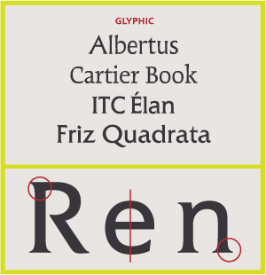

**Sans Serif Type Styles**  
**Grotesque Sans Serif**

These are the first commercially popular sans serif typefaces. Contrast in stroke weight is most apparent in these styles, there is a slight “squared” quality to many of the curves, and several designs have the “bowl and loop” lowercase g common to Roman types. In some cases the R has a curled leg, and the G usually has a spur. This category also includes more modern, sans serif designs patterned after the first grotesques. Stroke contrast is less pronounced than earlier designs, and much of the “squareness” in curved strokes has been rounded. Normally the most obvious distinguishing characteristic of these faces is their single bowl g and more monotone weight stress.

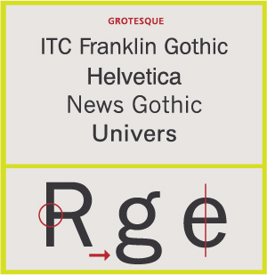

**Square sans Serif**

These designs are generally based on grotesque character traits and proportions, but have a definite and, in some instances, dramatic squaring of normally curved strokes. They usually have more latitude in character spacing than their sans serif cousins, and tend to be limited to display designs.

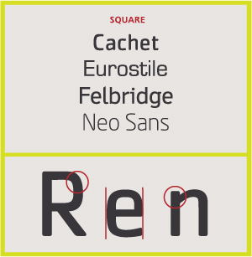

**Geometric Sans Serif**

Simple geometric shapes influence the construction of these typefaces. Strokes have the appearance of being strict monolines and character shapes are made up of geometric forms. Geometric sans tend to be less readable than grotesques.

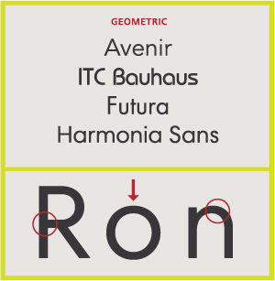

**Humanistic Sans Serif**

These are based on the proportions of Roman inscriptional letters. Frequently, contrast in stroke weight is readily apparent. Typographic experts claim that these are the most legible and most easily read of the sans serif typefaces. Humanistic sans serif typefaces also closely match the design characteristics and proportions of serif types, often with a strong calligraphic influence.

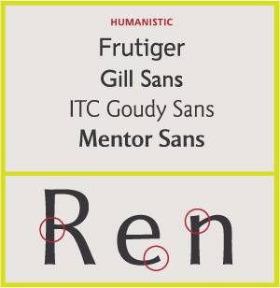

**Script Type StylesFormal scripts**

These typefaces are derived from 17th century formal writing styles. Many characters have strokes that join them to other letters.

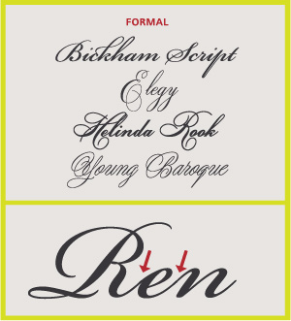

**Calligraphic Scripts**

These scripts mimic calligraphic writing. They can be connecting or non-connecting in design. Many appear to have been written with a flat-tipped writing instrument.

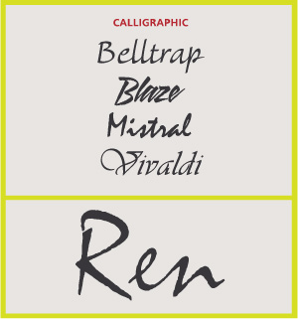

**Blackletter & Lombardic Scripts**

These typefaces are patterned on manuscript lettering prior to the invention of movable type.

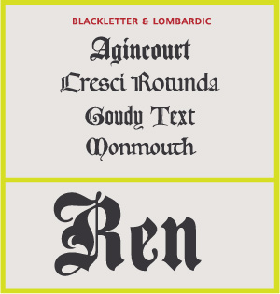

**Casual Scripts**

These typefaces are designed to suggest informality, as if they were written quickly. Many times they appear to have been drawn with a brush. Normally, character strokes connect one letter to the next.

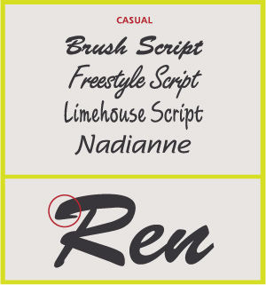

**Decorative Styles**

This is the largest category and also the most diverse. Rarely used for lengthy blocks of text, decorative typefaces are popular for signage, headlines and similar situations were a strong typographic statement is desired. They frequently reflect an aspect of culture – such as tattoos or graffiti – or evoke a particular state of mind, time period or theme. Many – such as psychedelic or grunge designs – are time-sensitive and fall out of fashion. Some decorative typefaces use unorthodox letter shapes and proportions to achieve distinctive and dramatic results. Some even appear three-dimensional.

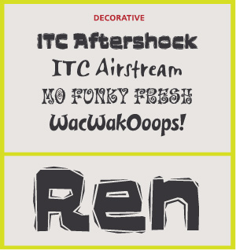

**MEASURING FONT SIZE AND SPACING**

**Type Size & Line Height**

In Web design, type size is set using one of two CSS properties, either font, which is a shortcut for setting several different font values or font-size, which is used only to set the size. The space between lines of text in a block can also be set in the font property or using the line-height property.

Font: Normal 16px/24/px century, serif;

Font-size: 16px

Line- height: 24px

**Setting Font-size & line height**

Font sizes can be set as part of the font property short cut or independently.

Any of the relative or absolute size-value units listed earlier in this chapter can be applied to set the font size or line height. Or you can use specific keywords to set absolute sizes, which can then be adjusted with relative-size keywords. Line height can also be set as a numeric value, without any units, setting the spacing between lines as a multiple of the font size.

**Understand how type is measured**

A typeface’s height is measured from the cap height (the height of the tallest capital letter) to the descended, with some breathing room added at the bottom to prevent characters on different lines from overrunning each other even if the line height is equal to the font size. The exact bottom buffer is set by the type designer. Taller uppercase letters—“b,” “d,” “f,” “h,” “i,” “k,” “l,” and “t”—often rise slightly above the cap height but are not included in the measurement. Although each character in the font might have a different visual height, they occupy the same amount of space vertically, even if they do not fill it.

Even if set to the same size, though, a font’s x-height will likely vary, leading some fonts to look taller than others, and often making them more readable, as is the case between Times and Georgia.

04-04.jpg

The width of a character is simply its visual width plus any space beside it. The space may vary from letter to letter and can be *kerned*—the process of adjusting letter spacing to optimize the legibility of that particular font. The one exception to this is mono space fonts, which always occupy the same width regardless of the character.

[04-05.jpg](javascript:popUp('/content/images/chap4_9780321679987/elementLinks/04-05.jpg'))

**Differing X- height**

The word “Fax” is displayed in Times and Georgia at the same font size, but notice that Georgia has a taller x-height. Taller x-heights can often make text more readable.

### Size fonts with absolute keywords for consistency, and avoid relative keywords

In addition to specific units of measurement, you can set font sizes using relative and absolute keywords. The keywords are self-explanatory, as good keywords should be:

* **Absolute-size keywords—**xx-small, x-small, small, medium, large, x-large, and xx-large-—set the type to a specific size as defined by the browser. Medium is the default browser font size.
* **Relative-size keywords—**smaller and larger—make text smaller or larger relative to its parent element’s font size. Unfortunately, different browsers use different algorithms to determine the relative font size change, making them unreliable for browser interoperability.

Table represents the pixel equivalent size of each of the absolute-size keywords as well as the effect of the relative-size keywords. As mentioned, each browser has a slightly different algorithm for computing relative sizes, so there is some browser variance, which is compounded when relative sizes are nested. Microsoft Internet Explorer and Fire-fox are the most consistent, but even they vary when using smaller font sizes.

Table 4.3 Font-size keywords with equivalent pixel sizes.

|  |  | smaller (px) | | | | larger (px) | | | |
| --- | --- | --- | --- | --- | --- | --- | --- | --- | --- |
| keyword | size (px) | IE | FF | Sa | Op | IE | FF | Sa | Op |
| xx-small | 9 | 6 | 8 | 9 | 8 | 10 | 10 | 11 | 11 |
| x-small | 10 | 7 | 9 | 9 | 9 | 13 | 13 | 12 | 12 |
| small | 13 | 10 | 10 | 11 | 10 | 16 | 16 | 16 | 16 |
| medium | 16 | 13 | 13 | 13 | 13 | 18 | 18 | 19 | 19 |
| large | 18 | 16 | 16 | 15 | 14 | 24 | 24 | 22 | 22 |
| x-large | 24 | 18 | 18 | 20 | 19 | 32 | 32 | 29 | 29 |
| xx-large | 32 | 24 | 24 | 27 | 26 | 48 | 48 | 38 | 38 |

**Dispelling the above-the–fold myth**

For many years, the unbreakable rule of Web design was that if you wanted something to be seen, it had to be placed “above the fold.” That is, it had to be in the space of the page that is displayed without scrolling in the Web browser. The term comes from printed newspapers. Important stories would always be placed at the top of the page, above where the paper was folded in half, since those were the stories people would see when the paper was in a vending machine or in a stack with other newspapers.

Applied to Web design, the theory goes that if you want to ensure that your readers see the text, image, or advertisement you really want them to see, it had better appear on the page first. This leads to using small text sizes; crowding columns of text, headlines, and advertisements as close together as possible; and generally cramming every last pixel available with content. This makes a certain amount of sense if your assumption is that viewers hate to scroll. You will then want to concentrate all of their attention on those first few hundred vertical pixels between the top and bottom of the browser window.

There’s only one problem—this is a false assumption. At least it’s an assumption that is no longer as true as it might have once been. Modern Web surfers do not fear scrolling, nor do they seem to pay any more attention to the content at the top of the screen than that down below. In fact, it’s easy to make the argument that modern viewers have been trained to ignore the top of the screen because that’s where all of the “junk” is, like navigation bars and advertisements.

The imaginary fold line has so many variables, including screen resolution, browser, operating system, not to mention the unknowable variable of how large the viewers like their browser window to open, that it becomes pointless to try to figure even an approximate value. Instead, your time is better spent creating engaging designs that are inviting and easy to scan.

Although the range for absolute keywords is limited, they are an easy way to quickly apply a set scale to your type. Since relative font sizes are so inconsistently calculated between browsers, they are not recommended.

**Setting type size to scale for fluid typography**

Consider one fact of Web design: Everything on the screen is resizable, and there is nothing you can do about it. No matter what units you use, all it takes is a keystroke by the user to enlarge the text, potentially upsetting your carefully set type.

Learning to live with and take advantage of the vagaries of Web design will make you a better Web designer, and dealing with your font sizes expanding is no different.

So, the default size of text in a Web browser is medium or 16px. Rather than trying to set all of our font sizes individually, it is better to set a scale. Start with the body font size set to 100% (16px), and then use em values to scale from that size, as desired:

**Body {font-size: 100%; line-height: 1.125em ;}**

**h1 {font-size: 2em ;}**

**p { font-size: 1em;line-height: 1.5em; }**

**Setting a Fluid Font Size**

This code sets the base font size to be whatever the default size is set for the browser (we can assume that it is 16px unless the user has adjusted the value), then enlarges that size for headers and holds the same size for paragraphs while increasing the line height.

If you then want to reduce the overall size of text on your page and you are using relative values, you need only change the percentage value set in the body. For example, 75% would create a document with a base font size of 12px, scaling all other sizes proportionally.

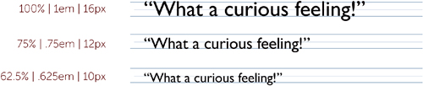

Alternatively, if you want more precise control, you can set a pixel value for the body font size to override the browser setting. This may cause some browsers to scale poorly, though, if the user manually increases the text size.

**Size header and body copy to improve scan ability and readability**

One truism of the Web is that readers tend to scan a page. Once they find what they are looking for, they go into reading mode. While we will deal with a more holistic approach to creating scan able text in Chapter 6, the most immediate and reliable way to guide the reader’s eye to important content is through a texture of type sizes. By treating the major page components—headers and body text—with a consistent scale for size, you can create a rhythm that improves scanning ability.

Heading sizes range between 18 and 32 pixels, while the most popular font sizes for body copy range between 12 and 16 pixels. Smaller font sizes for body copy may be encountered, but they are generally too small for comfortable reading and should be avoided.

A general rule of thumb is that the largest header font should be roughly twice the size of the body copy *or larger.*

*Body copy font size x 2<_ header font size*

With the lower-level headers gradually decreasing, on a consistent scale, in size toward 1em.

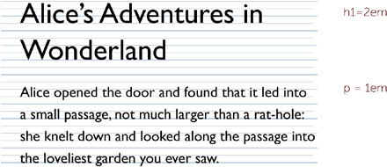

One important factor to keep in mind while determining your font size is that 16px is the default font size set by browsers. Text is intended to be at least that large for easy reading. Many designers size body text x-small (10px to 11px) in the belief that it looks better and is easier to design with, especially if you are concerned with getting everything above the imaginary “page fold” or scroll line (see page 112 for more about this). However, larger fonts with a judicious use of white space will create text that is easier to scan and read. You need to give your body copy enough breathing room.

**Choose a line height that gives your body copy breathing room**

Beyond the size of the text, one of the most frequently overlooked factors in creating readable text is the line height and the width of the column in proportion to the font size. It’s important to stress that line height is not the space between lines of text—as it is often mistakenly thought of—but the space from the baseline of one line of text to the baseline of the next line of text.

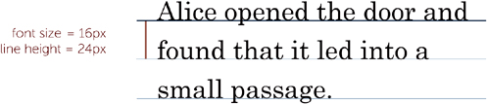

A minimum font size to line height ratio of 2:3 is recommended for any extensive body copy:

**Body font size × 1.5 ≈ line height**

So, a font size of 16px would require a line height of 24px or higher. To simplify matters, you could apply a line height of 1.5em, 150%, or just set a numerical value of 1.5. All of these will add the correct line height, regardless of how the copy is resized.

**Line-height: 24px;**

**Line-height: 1.5em;**

**Line-height: 150%;**

**Line-height: 1.5;**

**Setting a healthy line height**

All four values will have the same effect on text with a font size of 16px

In addition to font size, column width affects the optimal line height. Narrow columns and shallower blocks of text, such as headers, require less line height to be quickly scan able. Generally speaking, you can reduce the font size to line height ratio in this case as low as 1:1.125. In order to preserve a more uniform page grid, however, designers often keep the line height consistent regardless of the column width, and use font, style, and color changes to better differentiate columns.

**Choose a column width that will not tire your readers out**

Another important consideration for readability is the column width. Reading slows the longer a column grows—after a certain amount. A comfortable column width is easily derived from the page’s base font size. Although not an absolute and dependent on the typeface, a good rule of thumb to determine a comfortable column width is to multiply the font size by 28:

**Body font size × 28 ≈ column width**

This is a rough value. The multiple can range anywhere between 25 and 33, depending on your preference. Generally, though, if we assume a font size of 16px for our body copy, a comfortable column width will be around 450px.

Again, ems can come to our rescue to simplify matters, by allowing us to set a column based on the font size:

**Width: 28em;**

**Setting column width**

Set a fluid width to take full advantage of the screen without creating uncomfortably wide text.

For a fluid design that makes optimal use of the available screen real estate, set the maximum and minimum column widths within the comfort range:

**Min-width: 25em;**

**Max-width: 33em;**

The column width will expand or contract as space is available within the Web design, but never stretch too wide or too narrow for comfortable reading.

**Measuring fonts in reinsertion cases.**

In actual case work, font measurement is often performed by a document examiner in order to determine if has been inserted in previously printed text. Except that newer technology is being used, these cases are identical to the classic typewriter reinsertion technology is being used, these cases are identical to the classic typewriter reinsertion problems that have been examined by FDEs for 80 years or more. There are, however, some unique situations that can arise in documents that have been prepared using electronic fonts rather than a typewriter.

In the classic typewriter reinsertion examination, a glass or plastic grid was laid over a page of type in order to determine if the suspect text aligns horizontally, vertically and is parallel to the unquestioned portions of the page. This technique can still be used, to some extent, in typographic cases if the document has been prepared in a monospaced font such as courier and is set 12/12 (12 on 12). Because 12 points equals one sixth of an inch, it is even possible to use typewriter measuring plates in this situation. Be aware, however, that a printer’s internal bitmapped courier may use very different line spacing than the true type version of courier.

Clear plastic measurements grid can still be utilized quite effectively in typographic reinsertion cases if one has access to (one or more make) line spacing grids set on typographic units. Fortunately, it is fairly simple to create tables in most modern word processing programs and then set the vertical sell spacing to a given height in point units. For instance, making a one column table with 50 rows and then setting the spacing to 13.6 points will create a typographic grid with 13.6 point spacing that can then be printed on clear overhead transparency material. In some recent tests conducted by author, it was found that the finest increments that were being used by modern word processing programs were 0.5 decipoints. Although finer gradations may be possible with desktop publishing programs, it seems likely that a set of grids with point spacing, such as 13.0, 13.05, 13.1, 13.15, etc. will be sufficient for nearly all typical forensic line spacing, cases. Line spacing will be covered in some detail in the next section.

**Typographic Line Spacing**

The vertical distance between lines of type (interline spacing) has traditionally been known as leading. The term is derived from the thin silvers of lead that were used by printers to adjust the space between lines of type in a hand-set galley. Unlike the fixed line spacing associated with typewritten documents, typographic line spacing are generally adjusted for aesthetics and readability, predicted on the typeface and layout of the page. Since the measurement of line spacing in a document is probably the single most important aspect of a forensic typographic examination. Line spacing measurement are given in points and picas. There are (by modern typographic convention) 72 points to an inch, 12 points to a pica, and 6 pica to an inch. Most typographic lines that are computer generated, however will sit on fractional line spacing. As an example, typical line spacing used by modern laser printers when rendering a 12 point Times New Roman font are about 13.6 to 13.8 points. In order to accomplish the traditional settings, most word processing programs actually use a 10th of a point as their incremental unit. As far as the printer is concerned, however, the line spacing described above are simply locations on the printer’s internal grid system, the fineness of which is predicted on the output resolution of the device. For all practical purpose, however, line spacing grids incremented in 0.5 decipoints should suffice for document examiners conducting forensic examinations of computer generated documents.

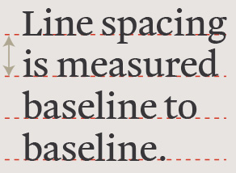

There are several reasonably practical ways in which decipoint unit measurements can be made. One of the method employed by the author involves the use of microscope measuring reticle that is graduated in 100 evenly spaced lines. The reticle is inserted into one of the eyepieces of a stereo-zoom microscope and calibrated in following way:

* 1. An accurate typographic ruler is placed under the zoom microscope with the pica and point gradations in view through the eyepiece.
  2. While looking through the eyepiece, the magnification of the microscope is zoomed so that 100 of the reticle increments occupy the same length as 10 points on the ruler. Each reticle step will then equal 1/10 of a point (a decipoint)

**Factors affecting Typographic Line Spacing**

Fortunately for FDEs there are only three types of people who create computer generated documents: (1) Typographic experts (2) Typographic expert wannabes, and (3) those who don’t know how to change the default settings if their life dependent on it.

Below are some of the questions we can ask concerning the variables that affect the line spacing’s found in a document.

1. If a word processing program’s default settings are considered to be the normal line spacing, then what factors affect these normal spacing’s?
2. How are the default line spacing of typographically set documents predetermined?
3. Should we expect to find that all 12-points font on a page would have the same interline spacing?
4. How much control do users typically exert on the line spacing of document they create vs. adjustments made by the software and hardware without a user’s intervention?

**Other factors that can affect line spacing’s**

* 1. **Without conscious user intervention:**
     1. An entire document is converted from one word processing program to another. For instance, there have been situations wherein a document conversion from WordPerfect (which was a favorite of law firms) to Microsoft Word format has resulted in odd line spacing’s and formatting anomalies.
     2. Portions of an older document (originally prepared in one word processing program) are copied/pasted into a new document being assembled in a different word processor. This sometimes occurs when “boilerplate” legal terminology from an older contract/agreement is used in a new document. FDEs have worked cases where the copied/pasted (inserted) terminology is set on different line spacing than the text that is typed into a new document.

Copied/pasted text may or may not undergo font substitution. There are many common look-alike fonts that can show up in business documents, for instance, Helvetica/Arial/Swiss, Times Roman/Times New Roman, Times New Roman/CG Times, Courier (internal printer version)/ Courier New (TrueType). If a new document is being prepared in Arial and the typist inserts the text from an older document prepared in Helvetica, one of the two things happen, (i) if the typist have a Helvetica on his or her computer, the pasted text will likely remain as Helvetica even though the surrounding text is in Arial; (ii) if there is no Helvetica on the machine that is being used to prepare the new document, it is likely that the pasted Helvetica text will be converted into Arial.

From a document examiners stand point, one must be aware that 12 point Helvetica and 12 point Arial (even though they are similar looking fonts) may well sit on different line spacing measurements on a page compare text rendered in the same font. This is particularly true in suspected printer reinsertion examinations.

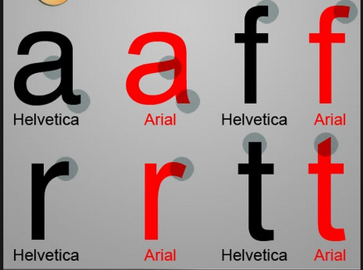

* + 1. Paragraphs that are copied/pasted from one document into another may carry their paragraph line spacing with them even if they are in the same font and prepared in the same word processing program. This can easily give the illusion that text has been reinserted if the line spacing in the earlier document had been forced by the author into an unusual spacing.
    2. If various parts of multi-page document are printed from different printers, there may be noticeable difference in the line spacing’s. Although this may be seem far-fetched, just such an occurrence has been directly observed in a forensic laboratory when a network printer went down during the printing of a long document, requiring that the latter pages be printed on a stand-alone laser printer. In a large organization it is also possible that several work groups will produce (and print) their sections of a document on different printers and then later compile them into final form.
  1. **With conscious user intervention:**
     1. The number of ways that an individual can vary the line spacing in a document are limited only by imagination and the capabilities of the software and hardware. Oddly enough, this is a good thing. As is true in every aspect of forensics, it is the quirky, rather than the normal, that provides the greater identification value. For instance, it may well be that an unusual combination of fonts and formatting found in anonymous letters is also found in suspect’s normally prepared correspondence.

Image……..

**Horizontal Measurement**

Most document examiners purchased extensive sets of grids in order to establish horizontal misalignments in a typed text as an aid to the identification of a particular machine. Modern word processing and use of true typographic characters, however, have dramatically changed the way we measure the questioned machine printed text.

There are many factors that can affect the horizontal spacing of a modern proportions, scalable font. Simply changing from Times New Roman typeface to a very similar looking CG Times face can cause a measurable difference in the horizontal length of a line of a text. Because there is a slight difference in the stroke widths of Times New Roman and CG Times, they will occupy different horizontal line lengths at the same point size. In addition, two other important factors can have a dramatic impact on horizontal text measurements: fonts can have different weights and can come in condensed and expanded versions.

There are more factors that need to be considered that can change the horizontal spacing of text. Justification of the right margin, for instance, will attempt to stretch a line of text so that the line lengths are all the same. The effect of full justification is to change both the distance between letters and the distance between words in order to make uniform line lengths. If kerning is turned on, it also can affect the inter-letter spacing by making micro adjustments to particular letter pairs so that they are more aesthetically pleasing. Finally, some word processing software will have the ability to “fit to document”. If this feature is available, the operator can have the software attempt to adjust the text and line spacing to fit the document on a set number of pages.

**Typewriters**

The concept of a typewriter dates back at least to 1714, when Englishman Henry Mill filed a vaguely-worded patent for "an artificial machine or method for the impressing or transcribing of letters singly or progressively one after another." But the first typewriter proven to have worked was built by the Italian Pellegrino Turri in 1808 for his blind friend Countess Carolina Fantoni da Fivizzano; unfortunately, we do not know what the machine looked like, but we do have specimens of letters written by the Countess on it. (For details, see Michael Adler's excellent 1973 book [The Writing Machine](http://site.xavier.edu/polt/typewriters/tw-resources.html). Carey Wallace's 2010 novel [*The Blind Contessa's New Machine*](http://books.google.com/books?id=UvjgnwAKjD4C) is based on the relationship between the Countess and Turri.)

A typewriter by definition is a small machine, either electric or manual, with type keys that produced characters one at a time on a piece of paper inserted around a roller. Typewriters have been largely replaced by personal computers and home printers.

Christopher Sholes was an American mechanical engineer, born on February 14, 1819 in Mooresburg, Pennsylvania, and died on February 17, 1890 in Milwaukee, Wisconsin. He invented the first practical modern typewriter in 1866, with the financial and technical support of his business partners Samuel Soule and Carlos Glidden. Five years, dozens of experiments, and two [patents](http://inventors.about.com/od/inventing101patents/f/What_patent.htm) later, Sholes and his associates produced an improved model similar to today's typewriters.

**Typeball machines**

The IBM ® Selectric typewriter was a radical innovation that completely disrupted the business typewriter market. It transformed the speed, accuracy and flexibility with which people could generate the written word, and helped pave the way for the use of typewriter keyboards as the primary method for humans to interact with computers.

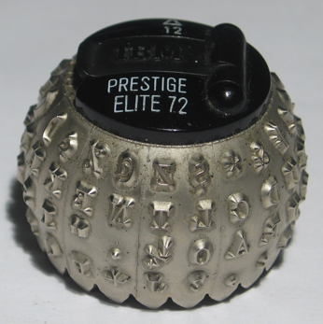

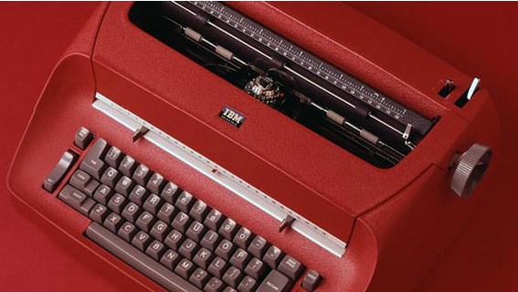

The Selectric typewriter, launched in 1961, was an overnight hit. “Sales of [the Selectric] in the first 30 days exceeded the forecast for six months. We figured in our branch office that we’d sell 50 or 60 and sold 500 to 600,” IBM salesman John Vinlove told *USA Today* in 1986 for a story about the typewriter’s 25th anniversary. The manufacturing facility expected to make 20,000 Selectric typewriters in its first year. By the end of 1961, they had orders for 80,000. And by 1986, more than 13 million Selectric typewriters had been sold. For more than 25 years, the Selectric was the typewriter found on most office desks.

With 2800 parts, many designed from scratch, the Selectric was a radical departure even for IBM, which had been in the typewriter business since the 1930s and was already a market leader. It took seven years to work out the manufacturing and design challenges before the first Selectric was ready for sale.

At the physical heart of the Selectric typewriter’s innovation was a golf-ball-shaped type head that replaced the conventional typewriter’s basket of type bars. The design eliminated the bane of rapid typing: jammed type bars. And with no bars to jam, typists’ speed and productivity soared.

The golf ball typing element was designed by an engineering team led by Horace “Bud” Beattie. The team members, according to a 1961 advertisement for the Selectric, “began their search by forgetting the past fifty years of typewriter design.” The first type head design had been shaped more like a mushroom, but under Beattie’s direction, IBM engineer John Hickerson revised the type head toward its ultimate spherical configuration.

One other innovation in the design—a changeable typeface—was borrowed from a turn-of-the-century model, the Blickensderfer typewriter. Although it is not documented, it is believed that the Selectric name was inspired by adding this changeable typeface selection to an electric typewriter. By making the golf ball interchangeable, the Selectric enabled different fonts, including italics, scientific notation and other languages, to be swapped in. With the addition in 1964 of a magnetic tape system for storing characters, the Magnetic Tape Selectric Typewriter (MT/ST) model became the first, albeit analog, word-processor device.

The aesthetic design of the Selectric was the responsibility of Eliot Noyes, an architect and industrial designer who served as consulting design director to IBM for 21 years. The elegant, curvaceous form he created followed the Selectric typewriter’s distinctive function: the golf ball, which moved across the page, eliminated the traditional carriage return. That enabled the Selectric to operate in a smaller footprint and opened up possibilities for a new profile. For the Selectric, Noyes drew on some of the sculptural qualities of Olivetti typewriters in Italy. The result was a patented, timeless shape, and a high-water mark for IBM’s industrial design and product innovation. “A writer’s machine if ever there was one,” noted Jane Smiley in *Writers on Writing, Vol. II.*

Less well-known is the Selectric typewriter’s role as one of the first computer terminals. While personal computers, notebook computers and word processing software may have relegated the paper-based typewriter to twentieth-century artifact, the Selectric was the basis for the keyboard input on the revolutionary IBM System/360. A modified version of the Selectric, dubbed the IBM 2741 Terminal, was adapted to plug into the System/360, and enabled a wider range of engineers and researchers to begin talking to and interacting with their computers.

Yet to IBM computer scientist Bob Bemer, the Selectric represented “one of the biggest professional failures of my life.” Bemer had pioneered the creation of the American Standard Code for Information Interchange, or ASCII, which still defines the alphabet for computers. When prototypes of the Selectric were already being manufactured at IBM’s typewriter plant in Lexington, Kentucky, Bemer reviewed the Selectric typewriter’s specifications. To him, the Selectric would make a natural computer keyboard. He argued that the type ball should be designed to carry 64 characters required for ASCII, rather than the typewriter standard 44. That would make it relatively easy to convert the Selectric for computer input. The response, as Bemer remembers it, was dismissive. As a result, the Selectric never spoke ASCII, instead employing a unique code based on the tilt and rotate commands to the golf ball. While Bemer viewed this as his failure, engineers continued to rig Selectric typewriters to function as the first generation of computer keyboards and input devices.

In 1971, the Selectric II was released, with sharper corners and squarer lines, as well as new features such as the ability to change “pitch” from 10 to 12 characters per inch and, starting in 1973, a ribbon to correct mistakes. The final model, the Selectric III, was sold in the 1980s with more advanced word processing capabilities and a 96-character printing element. But as personal computers and daisy-wheel printers began to dominate, the Selectric brand was retired in 1986.

**TYPEBAR MACHINES**

In the mid-19th century, business communications were increasing at a rapid pace and created the need for the mechanization of the writing process. Quite a number of different designs were developed and tested by various inventors.

In 1865, Rev. [Rasmus Malling-Hansen](https://en.wikipedia.org/wiki/Rasmus_Malling-Hansen) of [Denmark](https://en.wikipedia.org/wiki/Denmark) invented the [Hansen Writing Ball](https://en.wikipedia.org/wiki/Hansen_Writing_Ball), which went into commercial production in 1870 and was the first commercially sold typewriter. It was a success in Europe and was reported as being used in offices in London as late as 1909. Malling-Hansen used a [solenoid](https://en.wikipedia.org/wiki/Solenoid) escapement to return the carriage on some of his models which makes him a candidate for the title of inventor of the first "electric" typewriter. According to the book *Hvem er skrivekuglens opfinder?* (English: *Who is the inventor of the Writing Ball?*), written by Malling-Hansen's daughter, Johanne Agerskov, in 1865, Malling-Hansen made a porcelain model of the keyboard of his writing ball and experimented with different placements of the letters to achieve the fastest writing speed. Malling-Hansen placed the letters on short pistons that went directly through the ball and down to the paper. This, together with the placement of the letters so that the fastest writing fingers struck the most frequently used letters, made the Hansen Writing Ball the first typewriter to produce text substantially faster than a person could write by hand. The Hansen Writing Ball was produced with only upper case characters. By 1873 the first commercially successful typewriter was introduced: the Sholes and Glidden Type-Writer. This device is also the origin of the term typewriter.

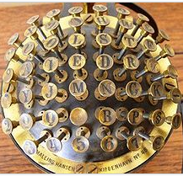

The basic **mechanical typewriter** became relatively standardized. Each key was attached to a **typebar** with the corresponding letter molded into its head (in reverse). By firmly striking a key, a typebar was brought into motion in order for the head to hit a ribbon, making a printed mark on a piece of paper. The paper was rolled around a cylinder, and this cylinder was mounted on a **carriage**. With every keystroke the carriage would advance horizontally to the next character on the same line. A carriage-return lever was used to move the carriage all the way back to the beginning of the line and roll up the paper one line vertically.

One important innovation was the use of a Shift key, which made it possible to use one of two characters on a single typebar. For letters these logically represented lower and uppercase versions of the same letter. For other characters it simply created more options for special symbols.

If any of these terms sound familiar - even if you have never used a typewriter - that should not come as a great surprise. Just look at your computer keyboard. There is an Enter or Return key, which is just like the original carriage-return lever. There is the Shift key, which works just like its mechanical equivalent. Modern computer keyboards have a lot in common with the old-fashioned typewriter.

**TYPEWHEEL MACHINES**

This invention relates to improvements in type wheel typewriters by which the construction is considerably simplified and the operation greatly facilitated. The invention presents a number of advantages for the construction of portable typewriters, but can be employed also for ordinary type wheel typewriters.

The main feature of the machine improved according to the invention is that the setting of the type wheel as well as the striking of the type on to the rollers is elected by an indexing, or typewheel-actuating member, which is guided by hand over the keyboard and the arrangement of which relative thereto is such, that the keyboard is not covered, but always. remains exposed, when -writing Further the machine is provided with an arrangement, which renders it possible to use the machine as ciphering machine, without changing the type wheel or the keyboard, by mutually displacing one of same against the other so that, when setting the proper letters on the keyboard, another type determined by the amount of displacement strikes on the platen. The deciphering is effected by writing the ciphered text on a machine adjusted in a similar manner, but in the opposite direction.

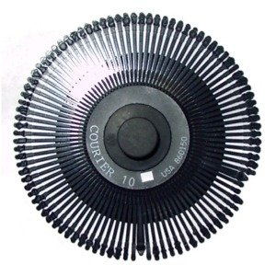

A typewriter, comprising in combination a machine frame, a platen in said machine frame, an oscillatable frame mounted on said machine frame, a keyboard fixed sloping towards the front on said oscillatable frame, an indexing arm above said keyboard adjustable parallel and perpendicularly thereto adapted to depressI said oscillatable frame, a shaft on said machine frame oscillatable in a plane perpendicular to the axis of said platen and adapted to swing towards said platen on said oscillatable frame being depressed, a typewheel rotatable and axially shiftable on said shaft, a bolt connecting said lever to said oscillatable frame, a spring between said machine frame and one of said oscillatable parts to hold said oscillatable parts in position of rest, a toothed wheel connected for uniform rotation with said type wheel, a grid plate meshing with the toothed wheel and curved so as to mesh with the toothed wheel during the oscillation of the lever, a bow extending around the front of said keyboard and -carrying said indexing arm on the upper side thereof, an adjusting element for said toothed wheel shiftably mounted on said machine frame, and a control rod hingedly connected to said adjusting element situated under of rest, a toothed wheel connected to said type wheel adapted to rotate in common with said type wheel, a control element for said toothed wheel, means for bringing said control element out of engagement with said toothed wheel, a bow extending over the front of said keyboard and carrying said indexing arm on the upper side thereof, a control rod connected with said control element under said keyboard, hinge connections between said control element said control rod and said bow adapted to allow the vertical movement of said indexing arm, and means for adjusting and fixing said indexing arm on said bow.

**DATING OF TYPEWRITING**

Frequently, it is possible to date a typewritten document through a study of the typewriting; a study combining the typewriting and the physical properties of the document upon which the typewritten material appears; or a study of properties wholly outside the typewriting itself. In rare instances relatively definite dates may be fixed, but in most cases a date will be a rough approximation and most frequently the principal evidence to be derived from such studies is a conclusion that a document was not typewritten until after its purported date. The evidence is negative. Nothing is proven by revelation that a document dated two decades previously was executed on a typewriting machine which existed then, but much is proven by revelation that a document of such date was executed on a typewriting machine which did not exist until a year or so previous to the examination. Though this is true, it is possible in many cases to establish that an older document executed on a typewriting machine which actually existed on its date, could not, in fact, have been written then. It is the purpose of this paper to explore all methods of dating typewritten documents.

**TYPE DESIGN**

Perhaps the ideal cases from the standpoint of the document examiner, and certainly among those most susceptible to rapid solution, are the problems where it is determined that a document dated a decade or so previous was executed on a typewriting machine bearing types designed and first manufactured a year or so previous to the examination. Over the years, manufacturers of all typewriting machines have redesigned letters, figures or characters within fonts which have been continued in use, or they have redesigned entire fonts or created new ones. The examiner maintaining an adequate basic type file is not likely to be mystified in attempting to date typewriting on a broad basis. But in certain instances fonts have existed without change for a number of years. If the examiner finds himself involved with certain designs of almost every typewriter builder, he faces a period of years during which no change was made. Typewritten documents whose dates are questioned may fall comfortably into these static or "no-change" periods, or as is so often the case, a "borderline" condition may exist. Fortunately, other features of the types may be considered.

**TYPE DEFECTS**

In some instances, a chronological study of type defects may be conclusive in dating typewritten material, and in cases where necessary specimens are procurable such a study should be made. Defects in typefaces or alignment appear as a result of continued usage. Damage and misalignment might develop in a new machine at varying periods, according to the quality of the typewriting machine, the abilities of the principal and any subordinate typists, and the amount of usage to which the machine is subjected. Certainly, if a machine at the end of a 10-year period has developed a dozen defects, they did not all occur at once but developed through use of the machine over the years. Consequently, if chronological specimens are available, the date of the development of defects may be established, and they, in turn, may serve to date a document. In applying a study of type defects to dating problems, certain cautions need to be heeded. The examiner must be certain beyond doubt that he is dealing with only one typewriting machine, and he must stand ready to prove that fact, or it must be proven by other testimony. Also, he must not allow himself to be misled by the possible replacement of certain individual types in a machine.

This latter feature, though, (with the possibility of producing repair records) may go far in the solution of a dating problem-a two-bladed weapon, actually.

**DIRTY TYPE FACES**

If a typewriting machine is used without frequent cleaning, typefaces become filled with dirt, and the loops of such letters as the '"o .e" g" "p" and others may become clogged with a combination of dirt, eraser particles, and ribbon residue. Once a letter opening is filled, the accumulated dirt packs and the surface becomes hardened and prints when it strikes the ribbon. Thus, an "o" may become a solid black circle. Letter closures become more pronounced with further use without cleaning. Therefore, if in a typewritten document part of the letter openings are clogged, while others are entirely free of dirt and clogging, it is obvious that there was a time differential between the two portions of the instrument.

It should be borne in mind that a machine might be cleaned at any time so that if page 1 of a suspect document has clogged types and page 2 does not, such evidence may constitute proof of a sort, but too much weight cannot be assigned. Contrariwise, if page 1 has entirely clean types and page 2 has dirty, clogged types, some rather substantial proof is at hand. Even here an admonition is in order. With a heavily inked ribbon and great usage, type clogging may occur in a short period of time. The exact period required for visible evidence to appear would be conjectural, but in lightly used machines, with a heavily inked ribbon, a clogging tendency has developed within a week or ten days. As with type defects, if specimens are available, a chronological study of the machine could be determinative.

**RIBBON CONDITION**

It is considered that there could be a few isolated instances where fabric ribbon condition might assist in the solution of a dating problem. The author takes an exceedingly dim view of this type of evidence for the reason that there are so many possible variables. For instance, while it is highly improbable, it is still possible that some typist might change a ribbon, even in the middle of a paragraph. Also, it is not completely impossible for a typewriting ribbon to go from new to worn condition in a short period if the machine involved is used a great deal. If chronological specimens of a machine are available for study, ribbon condition may assume great significance. Generally, while ribbon condition might aid in a few instances, the author would consider this evidence more definitive in showing a difference of a few hours or a day or so.

**OTHER DATING FACTORS**

Certainly, typewritten documents may be dated by evidence other than that connected with the typewriting machine used. This kind of evidence will serve to date any document-typewritten or otherwise. Certain of this evidence is of a devastating type, and its presentation can be completely effective.

Along this line, most conclusive evidence is that which establishes that the paper upon which the document is executed was first manufactured after the date of the document. Or, if the document is upon a printed form, establishment that the form was first printed after the date of the document is equally definitive.

The writer has handled several such cases in the past few years. In one case, a defendant in a $9, 0,000 lawsuit offered in his defense a copy of a resignation dated in June 1943, stating he mailed the original to his company in the month mentioned. If genuine, the resignation would absolve him from liability in the case. The paper was Woolworth's Cronicon, manufactured by the Hammer Mill Company, at Erie, Pennsylvania, and the complete, accurate records of this company revealed that the watermark in the copy of the resignation had been used first in February 1946.

Evidence equally decisive was discovered on a note for $12,000, dated November 10, 1944. This document bore a signature inscribed in a brilliant blue ball pen ink with a minimum of skips and goop marks; in other words, an instrument drawn long after November 10, 1944. In this case it was also found that the note form had been printed first some months after the date of the note. The note was typewritten, but the typewriting itself offered no evidence of fraud of misdating.

The identification of a particular typist may be conclusive in establishing the date of a document. As an example, it might be established definitely that a typist could not have been available for execution of a document pre-dating his or her employment and/or access to a given machine.

The date of a misdated document can itself sometimes offer decisive evidence. A will, as an ex ample, might bear a date when investigation will prove the testator was in the midst of an extended European tour and could not, in fact, have written his name on a document dated in his home town. More conjectural but deserving of some consideration would be the convenience of dating; that is, some consideration may be given to the use of a date which would conveniently lend countenance to the fraud being perpetrated.

**ADMISSIBILITY OF EVIDENCE**

The first discussion in this paper deals with the dating of a typewriting machine-and consequently a document it executed-by the design of its type. As was stated, changes in types by the various manufacturers make it possible to date typewriting within certain periods. In some instances, the discovery of the evidence might take a few moments, leaving only the necessity of presenting that evidence in a Court of Law. How may this be done?

Regardless of the method of presentation, one thing will have to be accomplished. Specimens of a machine must be introduced; that is, if the examiner is going to prove that the questioned machine was not manufactured until a certain date, he is going to have to offer proof by using standards. There is one nearly certain manner of getting specimens into evidence and that is to have present a fully qualified factory man-perhaps one who designed or approved or first aligned the type who can testify. There are, of course, numerous objections to this-financial and otherwise-and the fact must be faced that more often than not, the examiner will necessarily carry the burden.

Objection by opposing counsel might exclude testimony by a document examiner as to when any typewriting machine was first manufactured. The entering of such an objection should be anticipated in every case and a proper ground work laid in qualification of the examiner. The writer's personal preference (in any typewriting matter) is to place at the end of the regular qualification a question such as, "Now, in this case, typewritten material is involved. Would you state any special study you have made or any special qualifications you may have concerning the identification of typewriting machines?" Preferences may vary, but it would seem that this question or one similar should be asked at some point during qualification of the witness.

In reply to such a question it should be pointed out that the examiner has made a special study of typewriting equal to the number of years he has been engaged in examining documents. Certainly, this should be true. Visits to typewriter factories should be detailed, stressing the fact that such visits were not for the purpose of viewing the admirable mass production methods of the industry stressed to most visitors, but included extended talks with experts on type, the procurement of specimens, alignment, operating mechanisms of machines, and all features pertinent to the identification of typewriters. Naturally, a particular machine or machines will be involved in a given case and the examiner should be prepared to offer a history of type design and manufacture with particular emphasis on the types affixed to the make and model of machine or machines under scrutiny. Regardless of knowledge at hand, all facts should be checked and rechecked prior to embarking upon testimony in an important typewriter controversy.

In the matter of the actual introduction of standards, a thorough authenticating job must be accomplished. In some of the newer type designs IBM and other electrics, as well as certain manual fonts-the origin of the design is within the specific knowledge of the examiner; that is, he was actively engaged in the examination of typewritten material when the type first appeared. Perhaps original specimens were received from the factory or were taken from unused machines in the local offices of the typewriter manufacturer. In such circumstances it is probable that the standards would be admitted.

In criminal cases in the lower courts, there may be a tendency toward liberalism; that is, if the document laboratory of some enforcement agency possesses a specimen bearing a certain date, the Court might be moved to accept the standard. The same liberalism, it should be remembered, may not prevail in civil cases. Because of the peculiar nature of typewriting evidence, relatively few cases of the kind under discussion are actually tried and the author has been unable to find any precedent cases. But to recapitulate this discussion, it might be stated that in introducing typewriter standards, the examiner should do the best and most thorough authenticating job of which he is capable. The question of whether typewriter standards will be admitted will depend entirely upon the individual Court.