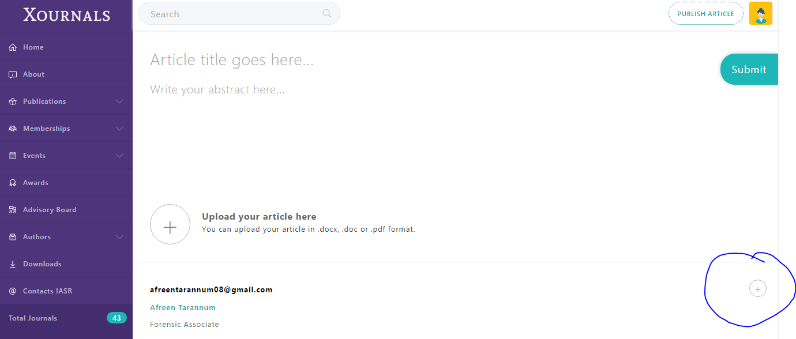

Add author link Should Be Visible

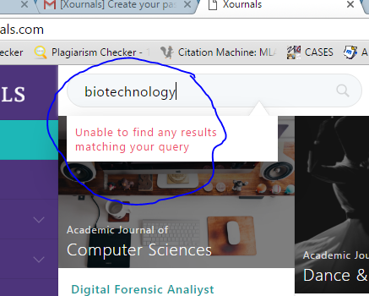

Not searching the terms in search option.

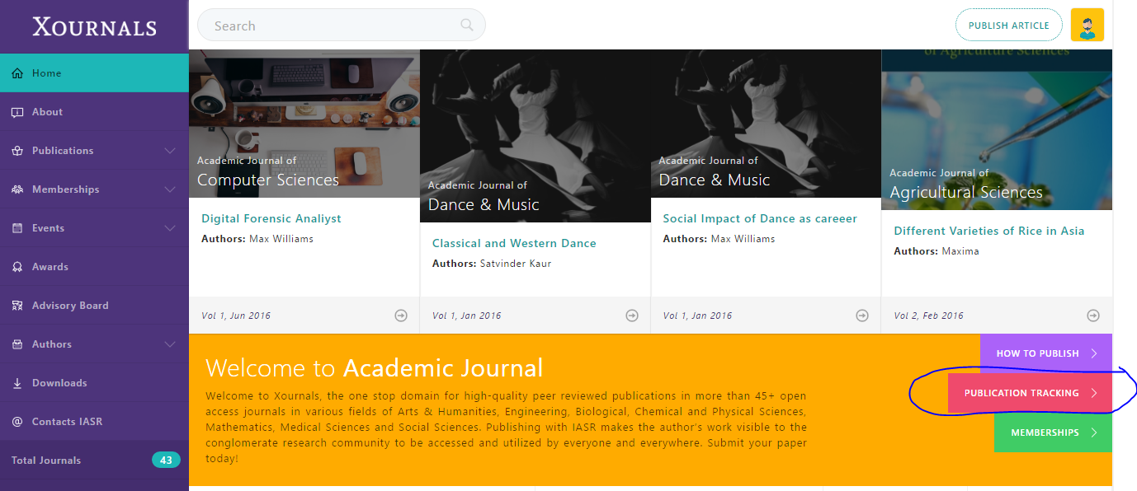

Publication tracking Not Opening

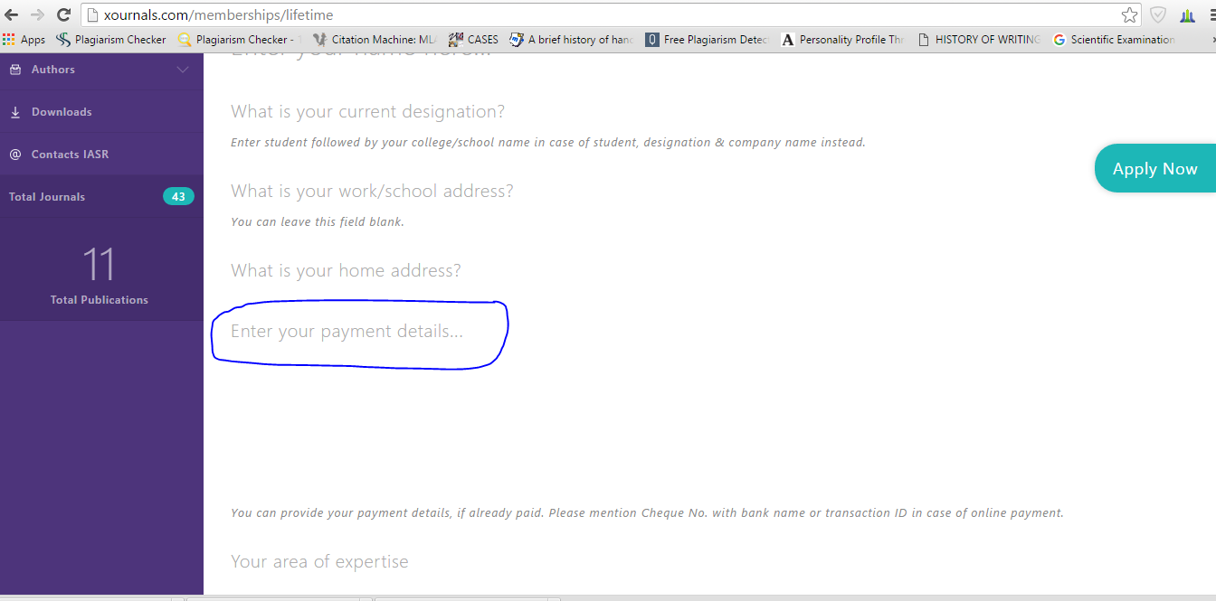

Mode of Payment must be mentioned in Payments details with what others detailed



My Publication – Cancel option not working

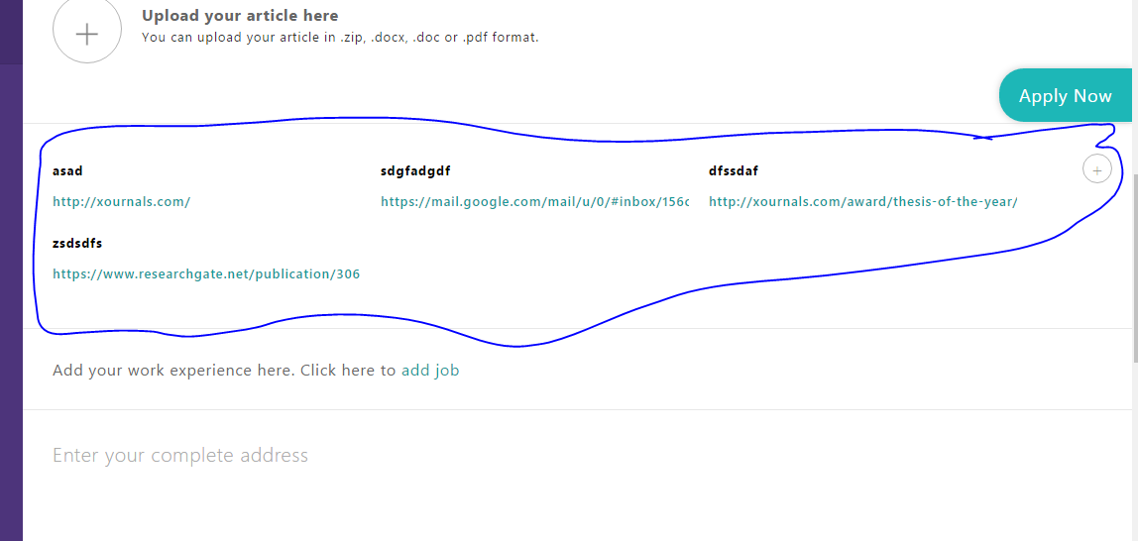

Complete link is not shown and link is not opening also + no editing after addition of details + separate option must be given for editing

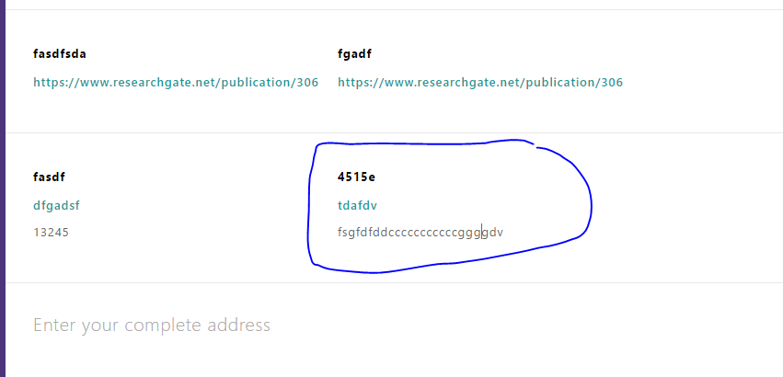

Award – Applying For Nomination – Add Papers + Add Job – after adding details there should be no editing …… editing option should be given separately to it \

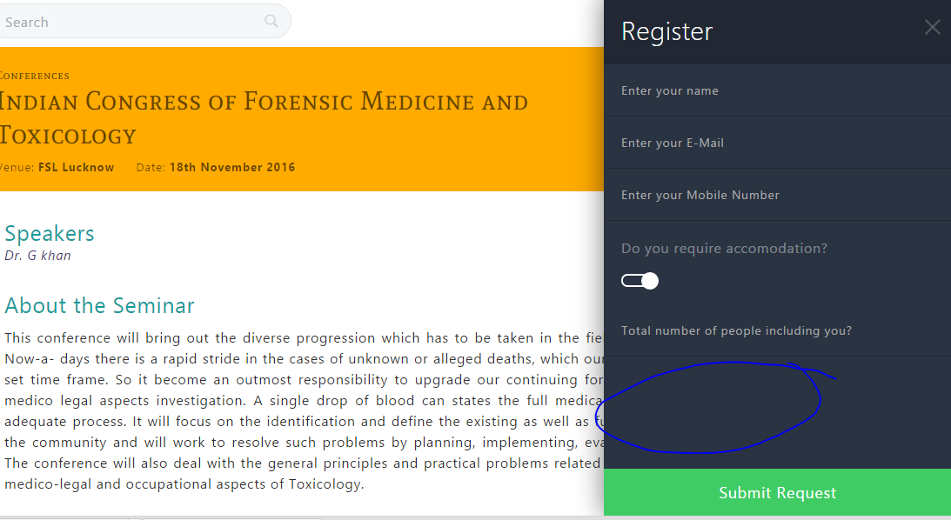

Events – ANY event – Register – mail not received after registration for payment details and acceptance

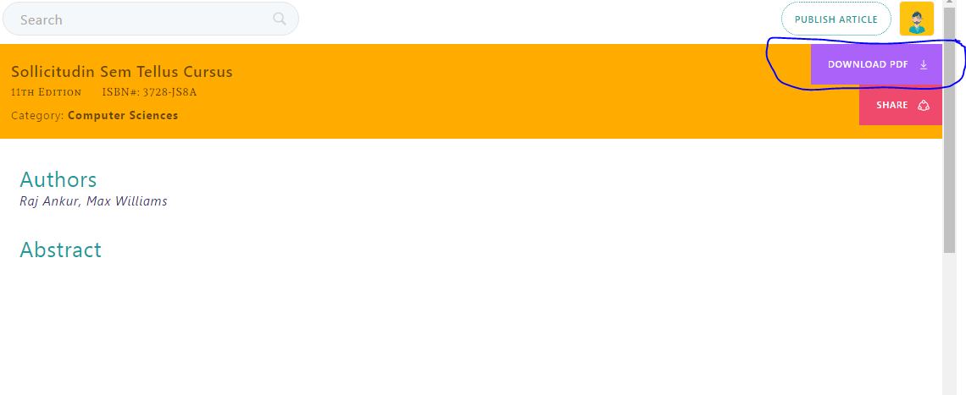

Publication – E-book- Download pdf – Pdf is not downloading … its just opening new tab