Academic Journal of Astrophysics and Planet



Xournals

ISSN UA | Volume 01 | Issue 01 | January-2019

**Dark Matter- A Telltale or Reality**

**Aaratrika Basu1**

**Available online at: www.xournals.com**

Received 19th September 2018 | Revised 22th October 2018 | Accepted 13th December 2018



*Abstract:*

*Our Milky Way gives the impression to be rooted in an extended dark matter halo, that is require to create a gravity in order to hold the stars and gas in the galaxy together and act like a binding force, although its presence is not hidden from the world, this paper mainly focuses on strengthening it more, considering the growth and gigantic experimental, and observational progress. As all the evidence are indirect and purely based upon gravitational effects of dark matter. Herein we will be discussing different front and opinion that astronomers have formed in order to define the presence of dark matter.*

***Keywords:*** *Dark Matter, Astronomers, Galaxy, Astro-Physics*



*Authors:*

*1. S. N. Bose National Centre for Basic Sciences, Kolkata, INDIA*

**Introduction**

Dark energy is assumed to be a property of space that bumpily constitute 68% of the universe. Whereas, dark matter set up about 27% and all the other things on earth, all of the normal matter adds up to not more than 5% of the universe.

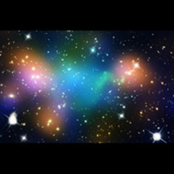

**Fig: 1 Distribution of Dark Matter, Galaxies and Hot gas.**

Some theories remains suggestive of dark energy being a new kind of dynamical energy fluid or field that supposedly fills all parts of space but has inverse action on expansion of the universe and is different from dark matter and normal energy.

**What is dark matter?**

Dark matter and Rubin rotational curve. Dark matter is a not known form of matter, it appears only when taking part in gravitational interaction, and neither does it emit nor absorb electromagnetic radiations.

It was first proposed in the year 1932 by Jan Oort a Holland astronomer, who noticed that the orbital paces or velocity of stars did not match their measure masses.

Explaining in layman language, it is basically an invisible substance that is as underlying scaffolding on which galaxies are built. More explanatory it is that glue which holds the visible matter in galaxies like star and gas together.

**Presence of dark matter:**

Dark matter is used to explain different independent gravitational effects at various astronomical scales, in galaxies and for that matter of fact across the full horizon.

Rendering to standards of “Cold Dark Matter” (CDM) model, dark matter is something that originates from quantum fluctuation in uniformity.

Hitoshi Murayama in his work “physics beyond the standard model and dark matter” has considered dark matter as mass density that is non luminous in nature and is not visible under telescope.

Zwicky was the one whose study strengthen the case of dark matter. In 1993 he reported “missing mass” in cluster of coma of galaxies, for this he had used virial theorem and studied motion of galaxies (Where motion of galaxy was assumed to be virialized). He in his study he affirmed the mass distribution in the cluster and stated that considerable portion of the mass was not visible.

I would like to support the theory of presence of dark matter by quoting from the study of rotation curves in spiral galaxies. For instance, it is known that in our galaxy (Milky Way) our solar system revolves at the speed of around 220 km/sec. When we use Kepler’s law, the total mass which is M (r) inside the radius r at the rotation speed for the given radius v (r) can be shown like:



Let’s assume that if the galaxy runs out of stars further than r, the speed of rotation is bound to decrease as:



Another study took place in 1963, at McDonald Observatory where, Vera Rubin while observing the rotation of galaxies found out an apparent difference in measurement along different axis, in the process of expansion of universe at the scale of 100 million light years. There was a clear discrepancy observed while studying galactic rotation curve, in between predicted angular motion of galaxies with respect to the motion.

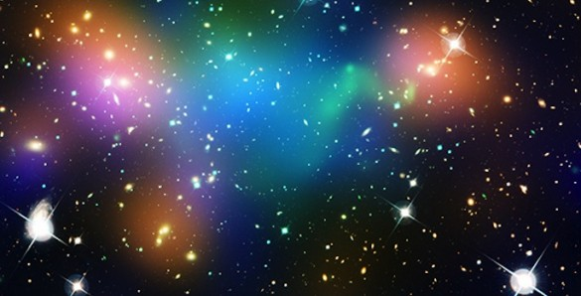

**Fig: 2 Abell 520 a gigantic fusion of galaxy clusters that is situated 2.4 billion light years away. It has left large lump of dark matter.**

Similarly few other astronomers found out that the rate of rotation of stars around particular galaxy were out of sync. Thorough observation showed that stars away from the galaxies’ center were moving at much higher velocities, this occurrence was termed as “galaxy rotation problems” which is till now considered to be an evidence of existence of dark matter surrounding spiral galaxies.

Rubin after thorough calculations pointed out that galaxies could hold to the least five to ten times of dark matter rather than ordinary matter.

In the era of 70’s astronomers came to a theory based on various evidences that galaxy would space out in the absence of stabilizing gravitational force of dark matter, by the time period of 1990’s an independent team at John Hoskin University of astrophysicists tried to calculated deceleration based on distant supernova to their surprise result was shockingly inverse, they found that the expansion wasn’t reducing down but to it opposite it was speeding up, so they came to a conclusion that some energy must be acting as counter to the gravity which they named to be dark energy.

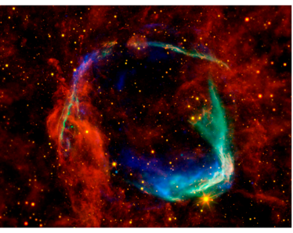

**Fig: 3 “Guest star” the very first stellar explosion observed by Chinese astronomers in 185 AD, Later it was fond that it was a type Ia supernova, the same kind used to discover dark energy.**

**Image courtesy of the following: X-ray, NASA/ CXC/SAO and ESA; Infared, NASA/JPL-Caltech/B. Williams (NCSU).**

In the year 2005 in Wales UK astronomers from Cardiff University, claimed that they have discovered a galaxy made entirely of dark matter, almost 50 million light years away inside the cluster named VIRGOH121.

It is presumed that the dark matter have much more mass than the visible component of the universe.

Data Distribution of Components covering universe:

|  |  |
| --- | --- |
| Ordinary Matter | 4.6% |
| Dark Matter | 23% |
| Dark Energy | 72% |

Dark matter/energy seems to encompass all through universe, but in varying intensity.

Cristopher Weinger, a physicist in 2012 at University of Amsterdam, found out a radiation strange in nature, around the center of our galaxy. He inferred that the glow can be a result generated from smashing of particles of dark matter, i.e. changing from invisible form to visible.

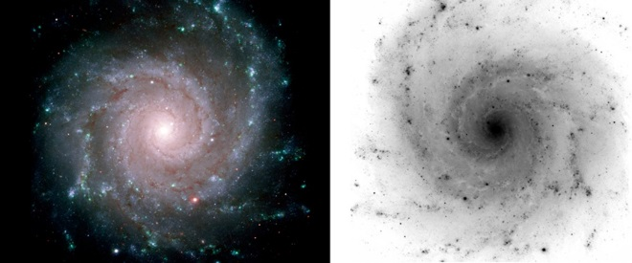

**Fig: 4 NASA/ESA/The GMOS Commissioning Team (Gemini Observatory)**

**Conclusion**

Majestic spiral galaxies such as ours i.e. Milky Way are really very hard to miss. It is easy to locate because of its signature winding arms of dust and gas, which holds thousands of glowing stars. Every galaxy is built upon this “dark matter” it works as the glue that holds together stars and gases, before 1932 it was not even heard of. Although astronomers claim that every galaxy is made up on it, it cannot be true in every case as nature holds many secret..



Baudis, Laura, and Jocelyn Monroe. “Focus on Dark Matter.” *Journal of Physics G: Nuclear and Particle Physics*, pp. 0954–3899., iopscience.iop.org/journal/0954-3899/page/Focus on Dark Matter.

[CDMS Collaboration], arXiv:astro-ph/0405033

“Dark Energy, Dark Matter.” *Nasa Science Beta*, science.nasa.gov/astrophysics/focus-areas/what-is-dark-energy.

G. G. Raffelt, “Dark matter: Motivation, candidates and searches,” 1997 European school of high energy physics, Proceedings edited by N. Ellis and M. Neubert. Geneva, Switzerland, CERN, 1998. 351p. (CERN-98-03) arXiv:hep-ph/9712538.

Hernandez, Marco, et al. “Theory of Dark Energy and Dark Matter.” *Indiana University Bloomington*, Sept. 2015, www.indiana.edu/~fluid/paper/HMW15.pdf.

Roos, Matts. “Dark Matter: The Evidence from Astronomy, Astrophysics and Cosmology.” *Coronell University*, arxiv.org/pdf/1001.0316.pdf.

<https://news.vanderbilt.edu/2013/06/10/dark-matter/>

<http://discovermagazine.com/2013/julyaug/21-the-possible-parallel-universe-of-dark-matter>

<https://www.space.com/20929-dark-energy.html>

<http://discovermagazine.com/2013/julyaug/21-the-possible-parallel-universe-of-dark-matter>.

*References:*