**MODULE-6**

**IDENTIFICATION OF SIGNATURES**

**OVERVIEW**

**Signature**

Handwritten signature practiced from ancient times and is held until today, and widely used as method of authentication in daily life. There is not a single area where signatures are not used. Signature of any person is an important distinguishing feature which is usually implemented for personnel identification or authentication. An increasing number of financial and business transactions are approved via signatures. Signature word is taken from Latin word “signare” which means “to sign”. A name, surname, mark or any distinctive feature made by an individual on a document or any object for authentication is termed as signature. The writer of signature is a signatory or signer. Sometime signature does not contain only one part of name, or sometimes a set of connected lines that do not resemble the name of the signer.

**“All writing can be signatures but all signatures cannot be writing.”**

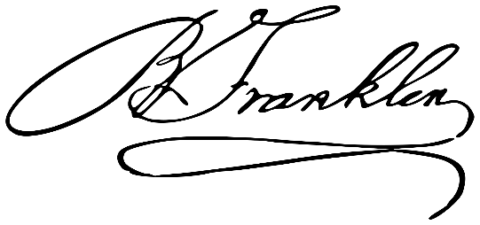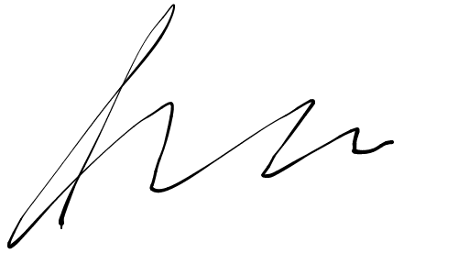

*Handwritten Signature’s*

It is well known fact that no two signature can be alike even if they are signed by the same person and if they are alike then one is **genuine** and another is **forged signature**. Now the problem arises here, when someone imitate the signature of the person with the purpose of fraud.

**GENUINE SIGNATURE**

The average problem of signature identification normally requires a minimum of fifteen to twenty known genuine signatures for comparison with a signature that is unknown or disputed. However, many problems of signature identification necessitate a greater number of known specimens for one or more reasons.

It is equally important for a document examiner to have not only a sufficient quantity of known standards for comparison purposes, but to also have the right quality of known standards. For example, fifty genuine signatures on gasoline credit card receipts may be worthless when used for comparison with a questioned signature on a last will and testament, whereas only five genuine signatures on legal documents might prove quite satisfactory.

It is suggested that when obtaining known comparison signatures, the investigator consider the circumstances listed below in order of importance:

1. Genuine signatures written nearest in date to the date of the questioned signature.
2. Genuine signatures written on similar material (checks, unlined stationary, similar printed forms, etc.).
3. Genuine signatures written under the same alleged or known circumstances.
4. Genuine writing written with a similar writing instrument (ball point pen, roller ball pen, fountain pen, pencil, etc.).
5. Often times canceled checks are of assistance, particularly because they have confirmed dates. If possible, canceled checks should be submitted in sequentially numbered groups of fifteen or more.

Characteristics of Genuine Signature:

* Anything of any kind that shows carelessness on the part of the writer are the signs of genuineness.
* Pen Movement
* Ball-Point Pen Movement
* Pen-lifts , Halts and Hesitations
* Increase in Pen-lifts due to Ill-Health

**FORGED SIGNATURE**

Forgery means the act of forging something or imitation of a document, signature, banknote etc. The act of [falsely replicating](https://en.wikipedia.org/wiki/Forgery) the [signature](https://en.wikipedia.org/wiki/Signature) of other person is referred to as Signature Forgery.

Osborn (1929) states that the successful forging of signature or stimulating another person’s writing by a forger involves not only copying the features of the genuine signature but also hiding his or her own personal writing characteristics.

Osborn (1929), one of the earliest experts in the field of document examination, observed that variations in handwriting are themselves habitual.

Signatures examined by the forensic document examiner for authenticity will eventually be categorized as genuine, or not genuine, if the examination leads to a definitive opinion.  “Forgery” in a strict sense is a legal term and it’s use as a conclusion should probably be avoided by the questioned document examiner.  Often a signature in of itself may be valid, but the manner in which it has been acquired or affixed to the document, or the sequence of events involved in its use are fraudulent.  The product of a rubber stamp or autopen is certainly not a genuine signature but is most frequently used in a previously authorized capacity.  While these signatures are not genuine, they are undeniably not forgeries.  Terms such as “Forgery” and “Fraud” are perhaps best used by the legal community.  Having said that, the reader may find that these terms are occasionally used in a descriptive manner throughout this text.

Characteristics observed in Forged Signature:

* Consciousness
* Signs of retouching
* Tremor
* Speed
* Pressure
* Patching
* Letter proportions
* Very close similarity between two or more signatures
* Blunt starts and stops
* Pen lifts and hesitation
* Presence of indentations or carbon outlines.

There are different method of forging someone’s signature:

1. Traced Forgery
   1. Direct Tracing
   2. Transmitted Light
   3. Carbon Paper
   4. Tracing Paper
2. Simulated Forgery
3. Spurious Forgery
4. Impersonation
5. Memory Forgery
6. Transplanting of Genuine Signature

**TRACED FORGERY**

In traced forgery, the counterfeiter prepare the outline of a genuine signature by a manual, mechanical or electrical method of tracing. There are different type of traced forgeries:

1. Direct Tracing: In direct tracing, document is positioned over the genuine signature being traced, and against a window as a source of light. The outline of the genuine signature that can be seen through the spurious document is followed carefully with the writing instrument.
2. Transmitted light: In transmitted light, document is positioned over the genuine signature being traced, and against a glass surface behind which a strong light source (such as a window, a headlight, a projector, a photographic printer, or a lamp) is situated. The outline of the genuine signature that can be seen through the spurious document is followed carefully with the writing instrument.
3. Carbon paper: the genuine signature to be traced is positioned over the spurious document, a piece of carbon paper is inserted between them and the outline of the genuine signature is followed by overwriting with a pen or an inkless instrument.

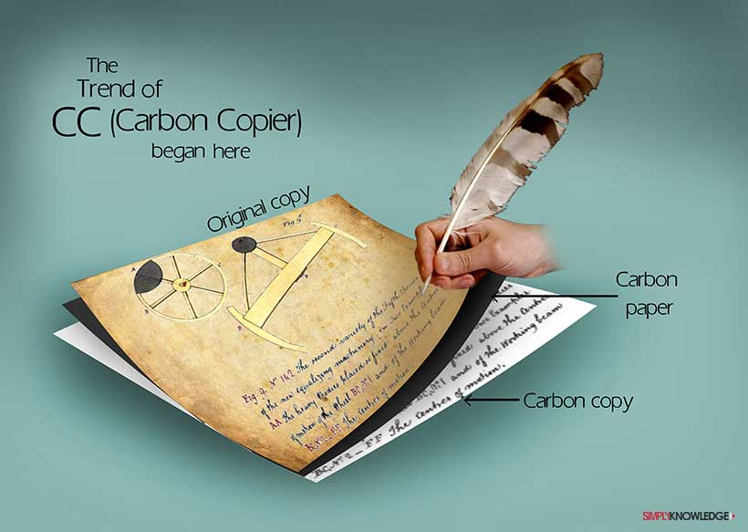

1. Tracing paper: the genuine signature is positioned over the spurious document on a tracing paper then with a hard pointed pencil outline the strokes of the signature over the document being forged. The impression is then inked in by following the course of the furrow with a pen.

